The Official Publication of ALOA—An International Association of Security Professionals

[www.aloa](http://www.aloa)

♦//

NEW Anti-Bump

|  |  |  |
| --- | --- | --- |
|  |  |  |
|  |  |  |
|  |  |  |
|  | | |

**PLUS!**

Greg Perry does a Little Research  
Stories in the Seruice Biz  
and More!

^-Z^/G/jT 303 BRECK H, CAMP CML PO BOX 47070 ATLANTA GA 30362-0070

**I..II.II.....II..IIm..I.III,mIIm.I.mIII...Im.III 1,11**

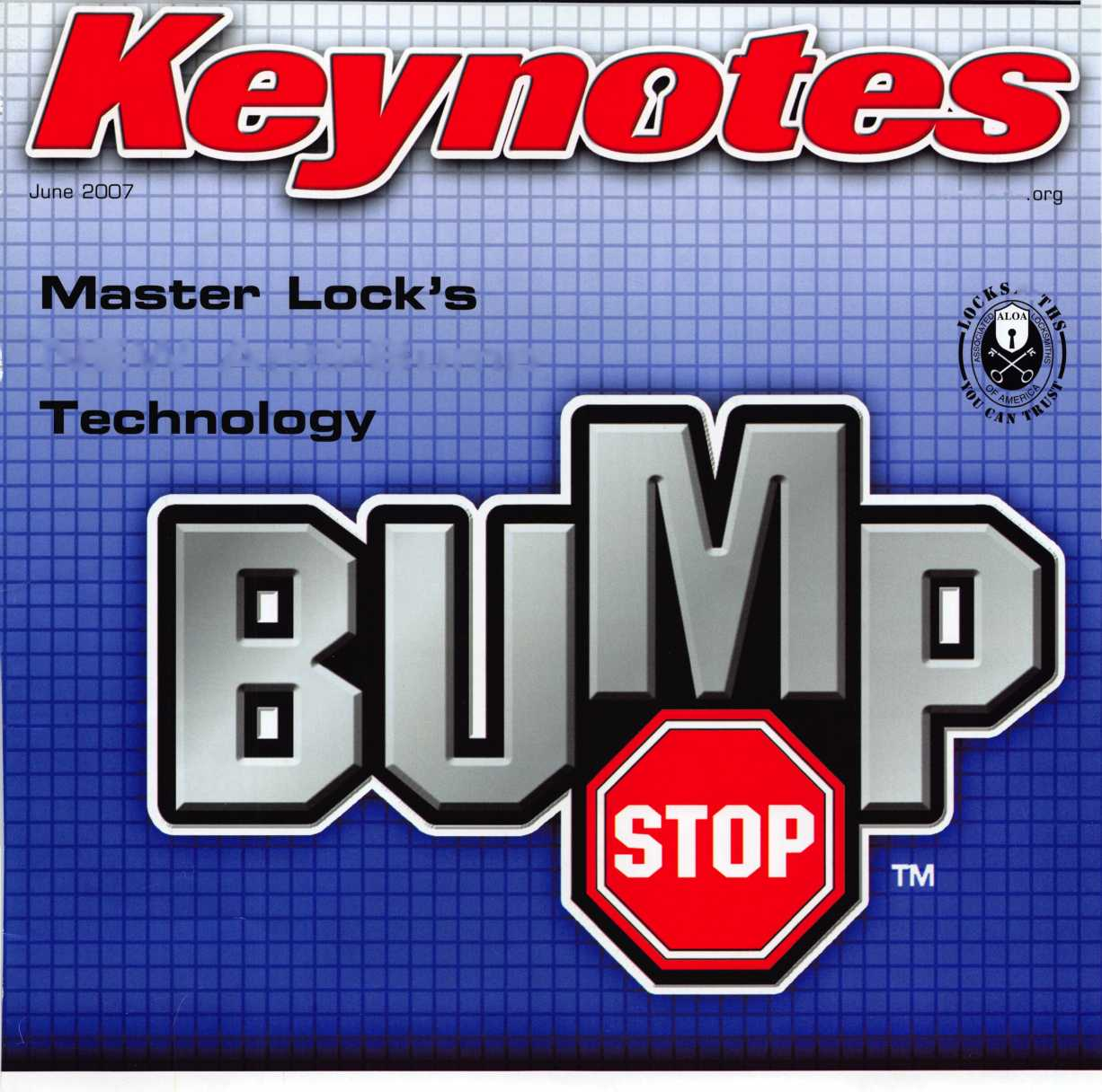

**OUR STAND**



**WE’RE IN BUSINESS TO HELP YOU**

**REDUCE DOWNTIME.**

**Commercial vehicle insurance designed to help you get back on the road.**

When your vehicle is out of business, so are commercial vehicle insurance as well as other

you. That's why Allstate provides fast and fair insurance products designed to help keep your

**LOCKSMITHS**

local Allstate agent offers business in the race. Are you in Good Hands®?

claim service. You!

CALL NOW TO SPEAK TO AN ALLSTATE AGENT NEAR YOU

**Allstate**

Subject to availability and qualifications. Allstate Insurance Company and Allstate Indemnity Company, Northbrook, IL. Allstate County Mutual Insurance Company, Irving, TX. Allstate New Jersey Insurance Company, Bridgewater, NJ. The "Cupped Hands" logo is a registered service mark and "Our Stand" is a service mark of Allstate Insurance Company. NASCAR™ is a registered trademark of the National Association for Stock Car Auto Racing, Inc. © 2007 Allstate Insurance Company, Northbrook, IL.

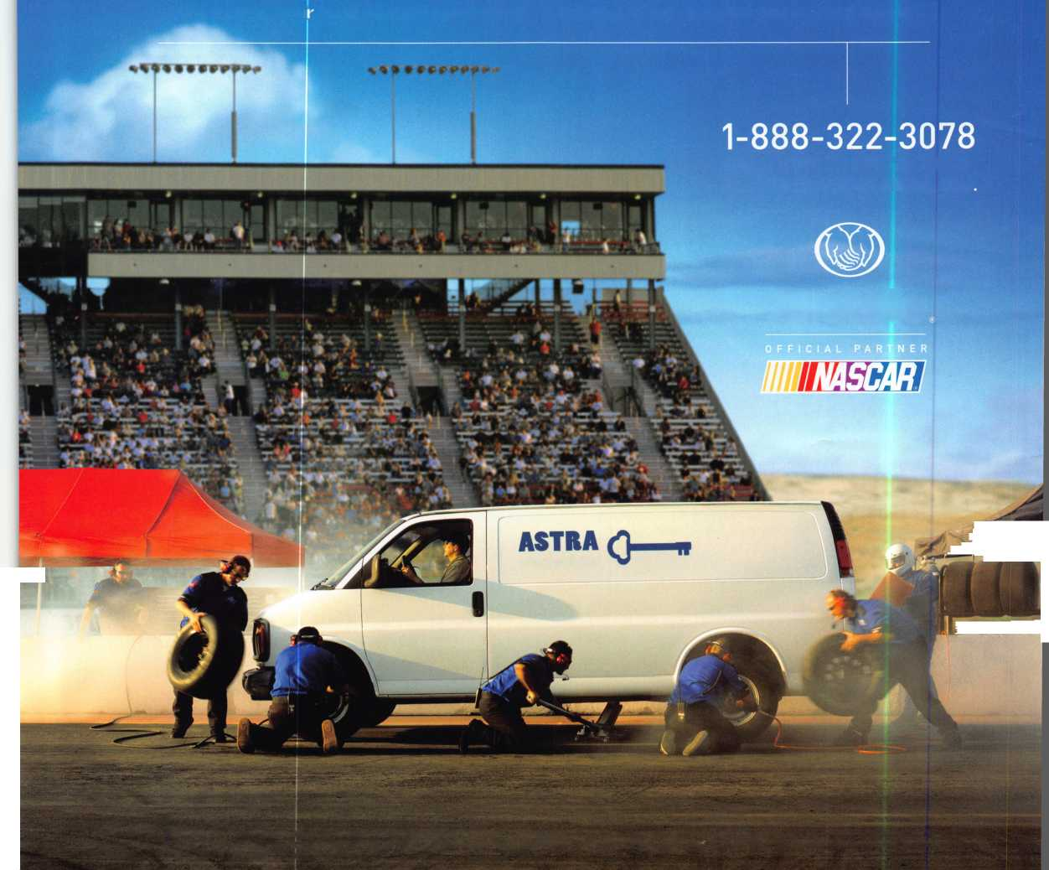

Fraud

A known phone scam tar-  
geting locksmiths and safe  
technicians has recently  
resurfaced. Here s how it  
works:

You get a call from an  
operator. If you haven't  
received a Hearing-  
Impaired-Relay call before,  
the operator explains the  
service. After that, the

operator is not supposed to talk to you except to  
read what the caller is typing.

The caller asks for a specific item. If you have it, he  
asks how many you have in stock “right now.” If you  
don't have it, he asks if you can order 10, 20, or 50  
of the item to have in stock the following morning. If  
you don't even carry the item, he asks, “What do you  
have in stock right now?” Whatever it is, he wants it  
— in bulk.

The caller wants to place the order with a credit  
card, but will sometimes offer to send a check,  
money order or cashier's check. None of these is  
any good. The credit card usually goes through,  
though, and the merchant thinks the sale is good. In  
fact, it may take weeks and several more fraudulent  
transactions with the same “buyer” before the mer-  
chant gets word the card was no good.

The caller gives a shipping address in Nigeria, some  
other country, or the U.S. The merchandise is picked  
up by a shipping company. The caller insists on get-  
ting the tracking number. He may even offer to  
arrange shipping or have the items shipped on his  
account so he can be sure to get it. If the package  
ships to Nigeria, this helps him pick it up. If it's sent  
somewhere else, he uses the tracking number to  
divert it to its true destination.

Throughout, the caller tries to create a sense of  
urgency, saying things like, “Run the card now while  
I hold.” His goal is to get the merchandise out the  
door before theft is detected.

ALOA/SAVTA members have reported that scam-  
mers often ask the victim to prepay the shipping.  
They always used the "hearing impaired" or other  
device apparently to prevent voice identification. Use  
of the service also makes it difficult to ask questions.  
The orders are usually so big that shop owners were  
less careful than they might usually be. At that time  
the orders were being placed from foreign, usually  
African, countries. They would say that the shipping,  
for currency exchange or some other reason had to  
be pre-paid by the seller. Sometimes the seller gave  
an authorization that amounted to a "blank check"  
for the shipping. The whole scam is just to get the  
shipping money. There is never a real purchase.

Alert

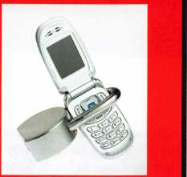

**BEAUTIFUL ON THE OUTSIDE. INTELLIGENT ON THE INSIDE.**

Finally, electronic access control that looks as good as it works. Introducing the 5V-1 Door Lock System from SimonsVoss - the world's first electronic access control system contained entirely inside the handle.

Backed bymorethanadecade of German engineering, this completely wireless, network-ready system can be used over 150,000 times without changing batteries. It’s time to experience the beauty of a keyless world.

[www.simons-voss.us](http://www.simons-voss.us)

414.421.2481

**SimonsiVoss**

technologies

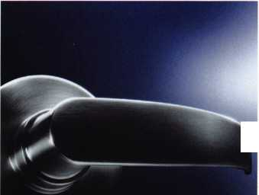

**presidential  
v i e w p o i n t**

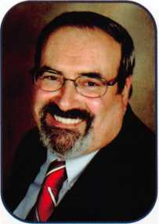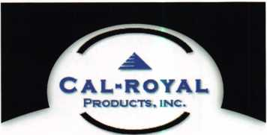

Cal-Royal Products. Inc.

**6605 Flotilla Street. City of Commerce. CA 90040 U.S.A.**

**Tel: (323) 888-6601 • (818) 888-6601 • (800) 876-9258  
Fax: (323) 888-6699 • (818) 888-6699 • (800) 222-3316  
E-mail: [sales@cal-royal.com](mailto:sales@cal-royal.com) • Website: [www.cal-royal.com](http://www.cal-royal.com)**

Sincerely,

Robert E. Mock

EXPLORER

Take 'er easy!

Dear Members,

The old cliche, "...in the blink of an eye," aptly describes the last two years. Representing ALOA has been for me, an exciting  
and fulfilling experience. The Presidency has afforded me the opportunity to visit and speak with our members all over the  
world. Our membership has been speaking out and even as I write this message, many of those ideas are being implemented.

Two years are indeed, too short to accomplish everything. It is my

hope that our association continues to forge ahead providing our  
membership with ever-improving services.

We all too often put things off to a more "convenient" time in our  
lives. I am here to tell you that there is no such time as "convenient".

I have heard more times, than not, when business slows up..., when I  
retire..., after the kids get married. As far as I know, we only have a  
one way ticket. What a shame to put off making life-long memories!  
Become something greater than yourself. Take that dream vacation

get-away. Take time to

smell the roses. Show up to an ALOA Convention and live life to the fullest. Take some time every day to reflect on something beautiful: a flower, a sunset, your friends.

At the end of May, I attended the European Locksmith Federation's Convention in Riga, Latvia. We were well represented by both American and European ALOA mem­bers. Our thanks go to members, Owe Bengtsson and Ed Roskelly for helping out at our booth.

The show was one of the largest and best attended ELF Conventions in recent years. I had the privilege of attend­ing and speaking at their board meeting. I spoke about associations working together through affiliation, which was the same message President Dave O'Toole addressed to his members. During the meeting, the Federation re­elected Mr. O'Toole again as their president and Jan Thorner as second vice-president. They also voted to admit Turkey into the Federation, bringing the number of countries to seventeen. Their 2008 convention will be in Athens, Greece.

Our Secretary, John Soderland and I will have already been in Dallas for the physical audit and special meeting for the election of our new Directors and President by the time you read this message. Good Luck to all!

After close to four decades around this industry, my wife Dee and I have made many friends traveling to many locksmith meetings. I have gained a wealth of knowledge along with business and technical expert­ise that only contact with our peers and fellow professionals can bring. These past two years have been exceedingly full and busy. I shall continue for the next four years as your Trustee, grateful for each minute and for each memory. Thank you again, for the honor and trust you have given me as your President.

Non Clutch Mechanism, "XP" Series

Fits All Major Manufacturers Thru Bolt Locations

COMMANDER

Clutch Mechanism, "Com" Series Large 1C Format

**2**

Keynotes • June 2007

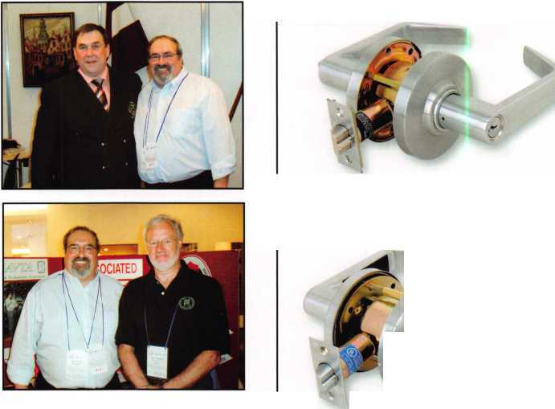

**TO OPEN**

PUSH FOR HELP

***ALARM CONTROLS CORPORATION***

***IF YOU NEED IT WE HAVE IT!***

***WE HAVE A COMPLETE  
LINE OF U.L. LISTED  
MAGNETIC LOCKS WITH  
A LIFETIME WARRANTY I***

***300 ,600 & 1200 POUND* ,. *MODELS FOR SINGLE & DOUBLE DOORS I***

***ALARM CONTROLS CORPORATION***

"ISBBSNlMB

***WE HAVE THE LARGEST  
SELECTION OF  
REQUEST TO EXIT  
STATIONS IN THE  
INDUSTRY!***

**PUSH TO EXIT**

© o

**EMERGENCY**

PUSH

EXIT

**PUSH** FDR **HELP**

**TS**-10 **MCK-2 KR-1 PS1-443 TS-26 TS-7**

TS-2 TS-4 EB-1

pusn

**EXIT**

PRESS

TO

OPERATE

DOOR

**EMERGENCY**

***IF WE DON’T HAVE IT  
WE WILL MAKE IT I***

(?)

**PD2-121 PN2-141 TS-16 TS-8**

**MCK**-4 **PBM**-1

**19 BRANDYWINE DRIVE P.O. BOX 280 DEER PARK,NY 11729  
PH: 800 645-5538 FAX: 631 586-6500  
EMAIL: [INFO@ALARMCONTROLS.COM](mailto:INFO@ALARMCONTROLS.COM)  
WEB: ALARMCONTROLS.COM**

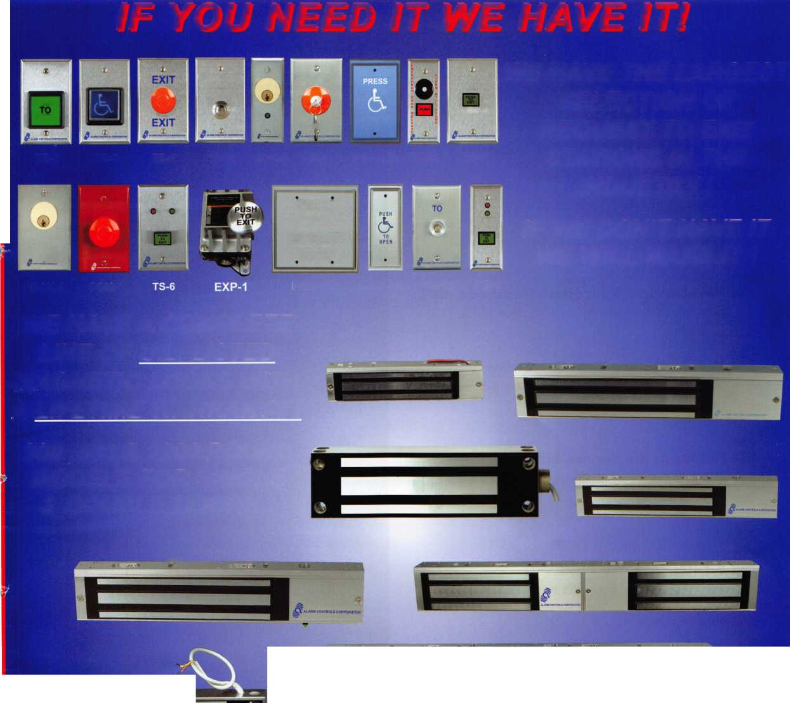

**feat**

BUMP STOP!

10

Bump Stop

Check out the NEW Anti-Bump techology from Master Lock.

by Billy Edwards, CML

**16**

Member Spotlight: Hans Mejlshede, CML

Hans has been a member of ALOA since 1974.

22

Mother Nature Meet SureStrike

Locksmith now have a weapon to battle and old-age problem. WMW answers the call.

**26**

Humor in the Service Biz

C.D. Lipscomb recounts familiar and humorous stories while on the job.

by C.D. Lipscomb, CML, CPS, CIL

**30**

A Little Research Pays Off!

Greg Perry tells us how a little research can go a long way.

by Greg Perry; CML, CPS

**Departments**

**u r e s**

**[ AD INDEX**

|  |  |  |
| --- | --- | --- |
| Allstate | Inside Front Cover | |
| SimonsVoss |  | 1 |
| Cal Royal |  | 2 |
| Alarm Controls |  | 3 |
| Strattec |  | 7 |
| Promet |  | 11 |
| Bianchi |  | 13 |
| Ben Jim |  | 15 |
| ALOA 2007 |  | 17 |
| INKAS |  | 19 |
| Sure Strike |  | 23 |
| Fax on Demand |  | 24 |
| Top Notch |  | 25 |
| IR |  | 27 |
| Town Steel |  | 29 |
| Amsec |  | 31 |
| Ultralift |  | 33 |
| Coast Safe & Lock |  | 35 |
| ALOA 2007 Business Seminars.... | | 37 |
| LetroTruck |  | 39 |
| A&B |  | 40 |
| Turn 10 |  | 40 |
| Locksmithing, UNL |  | 40 |
| PBP |  | 40 |
| Clearstar |  | 40 |
| HL Flake |  | 41 |
| North Bennet Street School. |  | 42 |
| DoorKing |  | 43 |
| Jet Hardware |  | 44 |
| Door Jam Armor | ..Inside Back Cover | |
| CCL |  | Back Cover |

L A

Presidential Execu ive 5

ViewP°int 2 Applicants 6

|  |  |  |  |
| --- | --- | --- | --- |
| Calendar | 8 | Classified | 34 |
| Core | 9 | Associate Members | 36 |

Legislative 38

Visit our NEW website at [www.aloa.org](http://www.aloa.org)

**executive**



Volume 53, Issue 6

Additional contact information for the ALOA Board is available on the ALOA website—  
[www.aloa.org](http://www.aloa.org) or by contacting the ALOA office at 3500 Easy Street; Dallas, TX 75247;  
(800)532-2562; FAX (214)819-9736; e-mail [aloa@aloa.org](mailto:aloa@aloa.org).

Editor & Director of Creative Services

Betty Southerland [betty@aloa.org](mailto:betty@aloa.org)

Advertising Sales

Kim Hammond voice: 817-645-6778

Fax: 817-645-7599 e-mail: [adsales@aloa.org](mailto:adsales@aloa.org)

Executive Director

Charles W. Gibson, Jr., CAE [charlie@aloa.org](mailto:charlie@aloa.org)

Associate Executive Director

David Lowell, CML, CMST [david@aloa.org](mailto:david@aloa.org)

Convention & Meetings Manager

Jo Anne Mims [joanne@aloa.org](mailto:joanne@aloa.org)

Operations/Membership Manager

Mary May [mary@aloa.org](mailto:mary@aloa.org)

Director of IT Operations

Greg K. Jackson [greg@aloa.org](mailto:greg@aloa.org)

Comptroller

Kathy Romo [kathy@aloa.org](mailto:kathy@aloa.org)

Membership Development Manager

Ellen R. McEwen [ellen@aloa.org](mailto:ellen@aloa.org)

Membership Coordinator Shelly Jett

Convention & Meetings Assistant Karen Lyons

PRP/Education Coordinator Shelley Melton

Mail Room Coordinator Kevin Wesley

Graphic Designer Margarita Garza

Accounting Coordinator Joyce Nixon

Executive Assistant Sue Langford

Assistant Education Manager Bob Stafford, CML  
Legislative Manager Tim McMullen

Contributors

Jerome Andrews, CML  
Paul Chandler, CRL  
Claire Cohen, CML  
Brian Costley, CML, CMST  
Eric Costley, CRL

Ray D'Adamo, CML Billy Edwards, CML Dan Graffeo, CRL,CMST Jim Hancock, CPL Jeff Nunberg, CML, CMST

Randy Simpson, CML, CPP Robert Stafford, CML Dave Thielen, CML Greg Perry, CML,CPS

Tom Seroogy

Charles Stephenson, CPS

Dennis Watanabe, CML, CMST

Mission Statement: The Associated Locksmiths of America, Inc. is dedicated to enhancing the professionalism, education and ethics among  
locksmiths and those in related sectors of the physical security industry. With approximately 10,000 members in the United States, Canada and the  
freeworld, ALOA is poised to help members obtain the knowledge, the strength, and the confidence to perform their role in the physical security field  
with pride and dignity. But it is only through active involvement and participation that ALOA can fully achieve its potential—and can help members to  
achieve theirs.

Policies: Keynotes® is the official publication of the Associated Locksmiths of America, Inc. (ALOA). Keynotes® acts as a moderator without approving,  
disapproving, or guaranteeing the validity or accuracy of any data, claim, or opinion appearing under a byline or obtained or quoted from an acknowl-  
edged source. The opinions expressed by the authors do not necessarily reflect the official views of ALOA. Also, appearance of advertisements and  
new products or service information does not constitute an endorsement of products or services featured by the Association. The Association does not  
accept responsibility for the inaccuracy of any data, claim, or opinion appearing in this publication, due to typographical errors on the part of the  
authors, Association staff or its agents.

Editor's Note: This publication is designed to provide accurate and authoritative information in regard to the subject matter covered. It is provided  
and disseminated with the understanding that the publisher is not engaged in rendering legal or other professional services. If legal advice and other  
expert assistance is required, the services of a competent professional should be sought.

Authors' Payment: Payment for eligible submissions to Keynotes will be based on the following criteria: topic, time spent and past contributions. Authors who  
regularly submit to Keynotes® are generally paid a higher rate. The latter is especially true of authors who write to fit specific editorial needs and submit said copy  
by Keynotes® deadlines. As a general guideline: Average payment for a 750 word, business or light' technical article would be $200. Payment for a 1500 word  
article involving significantly higher time and research efforts would be $400.

Payment will not be offered for articles submitted by ALOA employees or members of the ALOA Board of Directors (unless material is of a technical  
nature), nor for articles submitted by a company that promote that company's products or services. ALOA reserves the right not to pay for articles sub-  
mitted by an individual(s) that promote a particular company's products or services.

Disclaimer: The Associated Locksmiths of America, Inc., (ALOA), reserves the right to refuse any article for any reason. Additionally, ALOA reserves  
the right to edit, amend or modify any article submitted for publication in order to preserve technical accuracy, clarity, fairness or grammatical correct-  
ness. ALOA will make the best efforts to notify the author of any changes. The extent of ALOA's liability for any article or information contained there-  
in will be a notice of correction or retraction in the next possible issue.

Keynotes® (ISSN 0277 0792) is published monthly except for the combined June/July issue by The Associated Locksmiths of America, Inc.,  
3500 Easy St., Dallas, TX 75247-6416. Telephone: (214) 819-9733; FAX (214) 819-9736; e-mail [aloa@aloa.org](mailto:aloa@aloa.org). Subscription rates for  
members—$ 15.00 per year. Periodical class postage paid at Dallas, Texas. POSTMASTER: Send address changes to: Keynotes, 3500 Easy St., Dallas,  
TX 75247-6416. © Copyright 2003, All rights reserved. No part of the contents may be reproduced or reprinted in any form without prior  
written permission of the publisher.

President

Robert Mock  
(856) 863-0710

[president@aloa.org](mailto:president@aloa.org)

Secretary

John Soderland, CML, CMST  
(414) 327-5625  
secreta ry@aloa. org

Directors, Northeast

Tom Foxwell  
(410) 206-5772  
[nedirector@aloa.org](mailto:nedirector@aloa.org)

Robert D. DeWeese, CML, CPS  
(410) 285-0101  
nedirector@aloa .org

Directors, Southeast

Tom Gillingham, Jr., CML, CPS  
(615) 264-0747  
sed i rector@a loa. org

Ken Kupferman, CML, CPS  
(813) 232-7600  
sed i rector@a loa. org

Director, North Central

William Smith, RL  
(920) 893-5282

Guy Spinello, RL  
(815) 394-1000  
[ncdirector@aloa.org](mailto:ncdirector@aloa.org)

Director, South Central

CD Lipscomb, CML, CPS  
(903) 874-3522  
sed i rector@a loa. org

Directors, Southwest

Greg Parks, CRL  
(858) 271-1155  
swd irector@aloa .org

Julie McCluney, CRL  
(714) 636-5652  
swd i rector@a loa. org

Director, Northwest

Keith E. Whiting, CML, CFL  
(360) 601-5656  
n wd i rector@aloa. org

Director, International

Hans Mejlshede, CML  
(453) 539-3939  
eu rd i rector@aloa. org

Director, Associate

Dan Floeck  
(800) 231-4105  
asdirector@aloa .org

Trustees

[trustees@aloa.org](mailto:trustees@aloa.org)

Randy Simpson, CML, CPP  
(281) 2405959  
John J. Greenan, CML, CPS  
(773) 486.2030

William Young, CML, CPS  
(610) 647-5042

Past Presidents

2003-2005 William Young, CML, CPS  
2001-2003 Randy Simpson, CML  
1999-2001 John Greenan, CML, CPS  
1997-1999 Dallas C. Brooks  
1995-1997 David Lowell, CML, CMST  
1993-1995 Breck Camp, CML  
1991-1993 Henry Printz, CML  
1989-1991 Evelyn Wersonick, CML, CPS  
1987-1989 Leonard Passarello, CPL  
1985-1987 Joe Jackman, CML  
1983-1985 Stanley Haney, CPL  
1981-1983 Louis LaGreco, CPL  
1979-1981 John Kerr, RL  
1977-1979 Clifford Cox, CML  
1974-1977 Charles Hetherington  
1972-1974 Gene Laughridge  
1970-1972 William Dutcher, RL  
1968-1970 Constant Maffey, RL  
1966-1968 Harold Edelstein, RL  
1964-1966 William Meacham  
1962-1964 Robert Rackliffe, CPL  
1960-1962 Edwin Toepfer, RL  
1956-1960 Ernest Johannesen



Keynotes • June 2007



AZ

Window Rock

Andrew Segay

CA

Downey

Eric Ellsworth

Sponsor: Randy J. Main Lakewood

Kenneth Hebert

Sponsor: Stanley C. Ross Oceanside

Robin W. Varian

Sponsor: Gregory L Perry CMl, CPS Torrance

Joe Ramirez

Sponsor: Robert E. Mock Yountville

Don M. Thomas

Sponsor: Larry V. Wirth

*CO*

Loveland

Paul R. Newman

Sponsor: Gordon R. Racine CML

DC

Washington

Robert Mozie Jr

Sponsor: Philip A. Rovenolt CPL

FL

Leesburg

Doug J. Hotaling

Sponsor: Charles E. Batcke CPL, CPS Spring Hill

Jason Sessa

Valrico

Rolando Rivera

GA

Atlanta

Asher Ifrah

Brooklet Derek Edens

Sponsor: Bruce T. Rahn CRL Norcross

Laura A. Miles CRL

Sponsor: Breck H. Camp CML Sautee Nacoochee

Michael Tomlinson

Sponsor: John T. Grist CML, CPS

IA

Sioux Center

David J. Horstman

Sponsor: Elmer J. Howard

IL

Calumet City

Michael A. Giglio

Sponsor: Patrick J. Giglio

KS

Topeka

Ben L. Salsbury

Sponsor: Dana R. Hall CRL

LA

Gonzales

Stacey J. Ducote

Sponsor: Jedd J. Cox CRL

MD

Bethesda

Yair Kalush

Sponsor: Leonard S. Podgorski

ME

Hallowell

Jeffrey S. Truman CRL

Ml

Kalamazoo

Kevin A. Zeller

MO

Bridgeton

Brian Schaper

MT

Bozeman

Ryan O'Donnell

Sponsor: Richard O'Donnell

NC

Charlotte

James G. Raborn

Sponsor: Christopher J. Picerno CPL

NE

Omaha

George W. Huffaker

Sponsor: Harry L. Sher CML, CPS Wood River

James M. Reiter

Sponsor: Harry L Sher CML, CPS

NV

Henderson

Eric C. Going

NY

Beacon

Marco A. Gabin

Sponsor: Ori P. Brachfeld Buffalo

Daniel McGuire

OH

Parma

Gary R. Brown

Sponsor: Clay A. Hart CRL

OK

Lawton

Clarence L. Weber

Sponsor: Stephen D. Lee RL

PA

South Park

Garland O. Atkins

Susquehanna

Robert Coe

N Charleston

Jeffrey J. Waite

Travelers Rest

Mark M. Mullinax

Sponsor: Mark W. Evans CML

SD

Sioux Falls

Amber Grayson

TN

Bolivar

Jeff L. King

Sponsor: Dennis M. Jones

TX

El Paso

David E. Saucedo

Sponsor: Edward Saucedo Fort Worth

Miguel A. Nieves

Sponsor: William N. Bybee RL Houston

Tony G. Love

La Porte

Shawn M. Sharp

Barbados

St Michael

Curt Brathwaite

Sponsor: Donald H. Shiles RL

England

Alton Hampshire

Andy Thomas

China

Singapore

Sean Lee

Sponsor: Poh Kheng Hoe

Venezuela

Caracas

Javier Rey

w

The^appl,cants are scheduled for clearance as members of ALOA. The names are published for member review and comment within 30 days of this Keynotes issue date, respectively, to ensure applicants meet standards of  
ALOAs Code of Ethics. Protests, if any, should be addressed to the Membership Department and must be signed. Active Membership applicants (a) have worked in the industry two or more years. Allied Membership (AL)  
applicants are not locksmiths, but work in a security-related field. Apprentice Membership (AP) applicants have worked in the industry less than two years.



Keynotes • June 2007

**TRUSTED SOURCE. MANY SOLUTIONS.®**

jHJM’lf HJWUB

*m-wmmm*

PROGRAMSJNiCilDi:

* Audi 00- 04 A6,01- 02 A8, 02- 04 A4
* Cadillac ’97-'01 Catera
* Chrysler, Dodge, Jeep, Plymouth ’98- 04  
  -Chrysler, Dodge, Jeep, CAN'05

(Selected models)

* ford MTS ’96- 05  
  -Ford CAN ’04-05 (Selected models)

-Honda 123 Acura/Honda Systems  
-Honda CAN ’03-04 Accord, TL&TSX

* Mitsubishi ’00-'05
* Nissan & Infinity ’97- 05
* Toyota & Lexus 01-’05
* VW 00- 05 Beetle. Golf, Jetta. Passat

**OUTSTANDING PERFORMANCE!**

Accurate and reliable 24-7 customer service

•Toll-free tech line and support!

• From STRATTEC, the world leader in automotive lock technology.

**KMIfelftlN!**

* Easy to use, quickly connecting to the 0BD port
* Includes all cables and connectors •Adds, erases and programs keys
* Program RKE fobs (selected models)
* Obtains immobilizer code for certain models
* Fully upgradeable
* Expandable database!

(See ;ittpy/afterniafket.strattefccom for a

complete list of vehicle program coverage.)

*mmm*

Optional software is available. Please contact Strattec Security Corporation for more information.

| KEY REBATE PttiRAM

As a COOE-SEEKE8™ owner you qualify for  
V a $1 rebate** for each Strattec Transpon-  
der Key purchased through your distributor.  
\ Transponder Keys that are purchased each

calendar year will qualify for this offer. Up  
to a $500 per year maximum.

3333 West Good Hope Road | Milwaukee, Wl 53209 | 877.251.8798

http; //aftermarket.strattec.com



©2007 STRATTEC Security Corporation. All Rights Reserved. AS6836-5/07

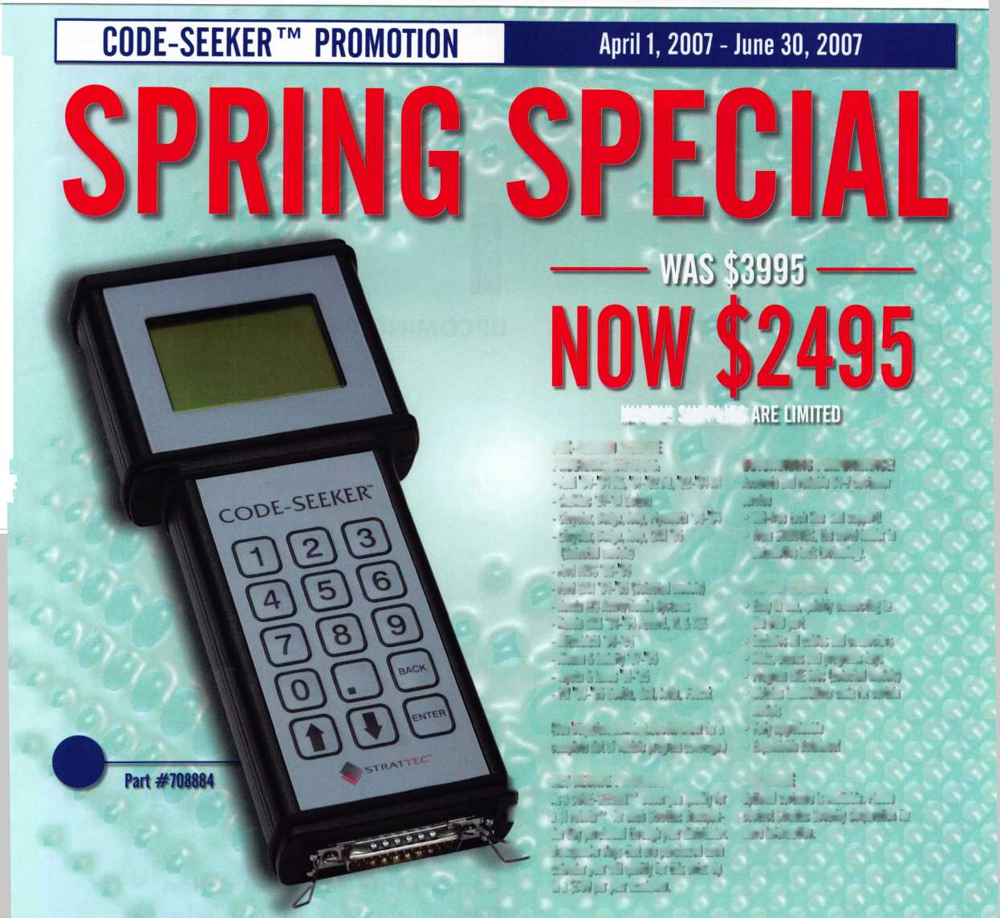

s

upcoming event



6/6 Counter Days • Minneapolis, MN Doyle Security Products RCI with Mark Schrantz • [www.doylesecurity.com](http://www.doylesecurity.com)

6/20 Doyle University Minneapolis, MN Doyle Security Products For more info [www.doylesecurity.com](http://www.doylesecurity.com)

6/23 VLA Meeting & Class Charlottesville, VA Contact: Elliot Paul Conner email: [va_locksmith@verizon.net](mailto:va_locksmith@verizon.net)

7/22-29

8/4-5

9/14-15

**111**

</)

|  |  |  |
| --- | --- | --- |
| ALOA '07 Convention & Security Expo Charlotte, NC  Associated Locksmiths of America  [convention@aloa.org](mailto:convention@aloa.org)  [www.aloa.org/convention](http://www.aloa.org/convention) | | 7/11 Counter Days • [www.doylesecurity.com](http://www.doylesecurity.com) |
| CLA Education  Long Beach, California  For more info:<http://clacen> index.Default.aspx?tabid= 1 | tralvalley.net/  54 | **** July, August, and September there will be no  Doyle University -  Classes will resume after the September Trade  Show. |

Doyle Annual Trade Show & Education • Prior Lake, MN Doyle Security Products Mystic Lake Casino [www.doylesecurity.com](http://www.doylesecurity.com)

**Z**

**o**

**o**

</>

UPCOMING ACE CLASSES UPCOMING PRP Sittings

|  |  |  |  |
| --- | --- | --- | --- |
| June 14-15, 2007 | Reno, Nevada • Clark Security Products  Basic Safe Lock Servicing, Transponder Technology  Joan Emrick • 858-9746737 | 6/2/07 | Saturday 9:00am • Largo, MD • Ed Korenge  Maryland Locksmith Association & NPALIPGCC [ed@lstinhardware.com](mailto:ed@lstinhardware.com) • 410-646-9900 |
| June 22-24, 2007 | Ft.Wayne, Indiana • Northern Indiana Chptr of ALOA  PRP Exam, Domestic Auto w/L-03 PRP, Foreign Auto w/L-04 PRP Jeremy Rodocker CML, CPS • [rodockers@hotmail.com](mailto:rodockers@hotmail.com) | 6/5/07 | Saturday 9:00am • Baltimore, MD • Ed Korenge  Maryland Locksmith Association • 410-646-9900 ed@ 1 stinhardware.com |
|  | 260459-1500 | 6/8/07 | Friday 8:00am • Dallas, TX • ALOA Certification |
| July 14, 2007 | Norfolk, Nebraska • Nebraska Chapter of ALOA  Advanced Topics in Master Keying w/L-31 PRP |  | ALOA Training Center • [education@aloa.org](mailto:education@aloa.org) 800-532-2562x104 |
|  | Elmer Howard • [safeman@cox.net](mailto:safeman@cox.net) • 402-676-8973 | 6/17/07 | Sunday 8:00am • Sparks, NV • Joan Emrick |
| July 22-29, 2007 | Charlotte, North Carolina  ALOA 51 st Annual Convention & Security Expo |  | Clark Security Products • [joan.emrick@clarksecurity.com](mailto:joan.emrick@clarksecurity.com) 858-974-6737 |
|  | 70 Full Day Classes • 35 Half Day Classes & Evening Seminars • ALOA Education • [education@aloa.org](mailto:education@aloa.org) | 6/17/07 | Sunday 1:00pm • Muskego, Wl • John Soderland, CML, CMST [prolock@aol.com](mailto:prolock@aol.com) • 858-974-6737 |
|  | 800-532-2562x101 • [www.aloa.org](http://www.aloa.org) | 7/27/07 | Friday 6:00pm • Charlotte, NC • ALOA Certification |
| August 20-25, 2007 | Dallas, Texas • ALOA Training Center  Six-Day Basic Locksmithing Course |  | ALOA 2007 Convention • [education@aloa.org](mailto:education@aloa.org) 800-532-2562x104 |
|  | ALOA Education • [education@aloa.org](mailto:education@aloa.org)  800-532-2562x104 | 8/25/07 | Saturday 1:00pm • Dallas, TX • ALOA Certification  ALOA Training Center • [education@aloa.org](mailto:education@aloa.org) |
| September 4-9, 2007 | Dallas, Texas • ALOA Training Center |  | 800-532-2562x104 |
|  | Six-Day Vault Lock & Time Lock Servicing Course  ALOA Education • [education@aloa.org](mailto:education@aloa.org)  800-532-2562x104 | 9/14/07 | Friday 8:00am • Dallas, TX • ALOA Certification  ALOA Training Center • [education@aloa.org](mailto:education@aloa.org) 800-532-2562x104 |
| September 11-15, 2007 | Anaheim, California • Clark Security Products  Safe Lock Manipulation, Safe Lock Servicing,  Transponder Servicing • Joan Emrick • 858-9746737 | 9/16/07 | Sunday 8:00am • Anaheim, CA • Joan Emrick  Clark Security Products • [joan.emrick@clarksecurity.com](mailto:joan.emrick@clarksecurity.com) 858-974-6737 |
| September 14-15, 2007 | Minneapolis, MN • Doyle Security Show  For a complete listing contact:  Kristina Larsen • 612-521-6226 • [www.doylesecurity.com](http://www.doylesecurity.com) | 9/22/07 | Saturday 9:00am • Sturbridge, MA • Steve McKinney  Yankee Security Convention • [info@yankeesecurity.org](mailto:info@yankeesecurity.org) 800-209-8266 |
| September 15, 2007 | Roseville, Ml • Locksmiths Security Association  Intermediate Auto Lock Servicing w/L-03 PRP  Marc A. Dearing, CRL • 810-2444038/[mkdearing@comcast.net](mailto:mkdearing@comcast.net) | 9/23/07 | Sunday 10:00am • Farmington, NM • 505-632-6641 Association Locksmiths of New Mexico  Wayne Wilkins, CRL • [classicrez@yahoo.com](mailto:classicrez@yahoo.com) |
| September 19-21, 2007  September 21-23, 2007 | Sturbridge, MA • Yankee Security Convention  For a complete listing contact: Stephen McKinney  800-209-8266 • [www.yankeesecurity.org](http://www.yankeesecurity.org)  Farmington, NM • Association Locksmiths of New Mexico  For a complete listing contact: Wayne Wilkins, CRL | 9/23/07 | Sunday 1:00pm • Muskego, Wl • John Soderland, CML, CMST [prolock@aol.com](mailto:prolock@aol.com) • 858-974-6737 |
|  | 505-632-6641 • [clasicrez@yahoo.com](mailto:clasicrez@yahoo.com) | Contact the ALOA Education | |

Department for a list of classes and training offered in-house.

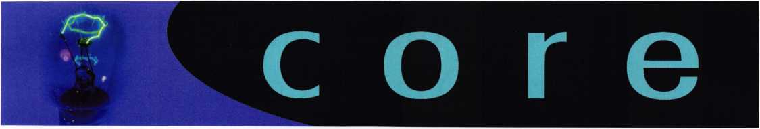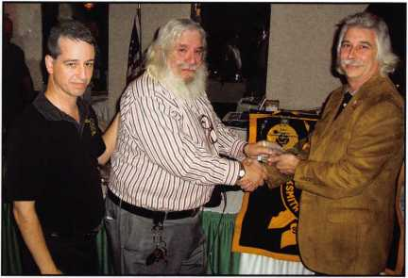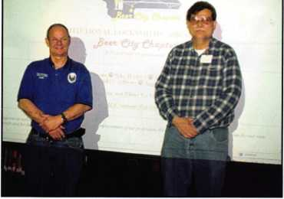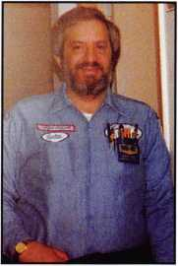

BEER CITY CHAPTER

ALOA Board Secretary John Soderland, CML,CMST, CIL (left) is shown with Beer City Chapter, Institutional Locksmiths

Association President James L. Swift at a recent chapter meet­ing

Lester Brodsky Accepts Award

The new MLA Award (Maryland Lifetime Achievement) was recently presented to Lester Brodsky.

Lester has been a locksmith since 1978 and has been an advocate and servant of the industry throughout his career. Lester worked with Bob DeWeese in the early nineties when the birth pangs of legislation brought them together as part of the Maryland Committee for Locksmith Legislation. Lester was quickly elected chairman of that com­

mittee and ded-  
icated countless  
hours in meet-  
ings and travel-  
ing throughout  
the state gath-  
ering input  
from anyone  
who was inter-  
ested enough  
to show up at  
the regional  
meetings.

For those who aren't fortunate enough to know  
Lester well, you're missing knowing one of this  
industry's true unsung heroes. While some  
locksmiths write articles and seem to burn up  
obscene amounts of bandwidth on the forums  
to the point that everybody knows their names,

Lester has never sought fame or recognition.

He simply works tirelessly behind the scenes  
with his only goal being the good future of this  
industry.

Behind his gruff exterior is a big teddy bear  
who is described as "one of the kindest gen-

tlest human beings that I've eve met". Bob DeWeese

said "I am blessed to be able to call him my friend".

**Video is Coming to This Years**

**|** ALOA Convention & Security Expo

Attend ALOA 2007

|online from anywhere

in the world!

COMING SOON AT:

aloa2007.tradeshowondemand.com

During the presentation of the award a letter from ALOA President Bob Mock was read and a short PowerPoint photo slideshow was presented by ALOA Northeast director Tom Foxwell.

**Easily Earn ALOA Certification Points!**

If you are planning to attend the 2007 ALOA Convention and Security Expo, please consider donating some of your time to assist in some key areas of the convention. Complete the form online at [http://www.aloa.org/2007convention/HTML/volun- teer.htm](http://www.aloa.org/2007convention/HTML/volun-teer.htm) to specify the date, time and activity that fits your schedule and skills. Once completed, fax back to 214-819-9736 attention: Ellen McEwen, Membership Development Manager. Assignments will be handled on a first come basis. If you have any questions please contact Ellen McEwen, Membership Development Manager at 214-819- 9733 ext 203. ALOA members will earn .1 points for every volunteer hour, which can be applied towards ALOA recertification!

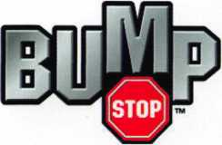

New Anti-Bump Technology

from Master Lock By Billy Edwards, CML

The Bump Keys we know today have had a few different names since they were invented in 1925. Nine keys or 999 keys has been a very popular name and there have been others. Until about two and a half years ago they were a well kept secret within the locksmith trade. They were such a well kept secret that prob­ably as much as 75% of locksmiths had never heard of them.

PATENT SPECIFICATION AfipIkttiM Out: *t 18,794j26. 251,810

Complete Lift- Du. f, 1916,

Complete Accepted: Uif IS, it *16*.

PROVISIONAL SPECIFICATION.

A Locksmith'* Instrument to Open ell Standard Makes oi  
Cylinder Locks.



**I, Obobok** Joan **Bab** os, of 292,  
Chapter Road, Wilietden, 5.W. 2,  
llrimb aubject. do hereby (Mar, the  
nature of this umntioa to be as  
6 follows: —

The instrument consist* of a metal  
cylinder, containing a hollow centre cote  
working on I spring. A planner ii  
ineertoa in Ike centre core. The Javen  
10 tion **Um** in the application of percussion,  
which operate* the plunger in the centra  
cure of spring cylinder, and also is the  
special shape of plunger need.

The mala] cylinder is approximately  
lb. 2 inches long, and T/, of an inch in dia-  
meter. The hollow centre core ia  
approximately 21;. inches long, thickened  
at one end, end work* on a spiral spring

inside the cylinder.

10 The ■

keyhole

plunger* see approximately 9*/«  
tong, shaped at ana and to fit the

e of the lock to ho operated upon.

Thera may be about 12 of thees plunger* required although some plungers will fit •1 or 4 different makes of looks. Each ** plunger ia cut to a serrated pattern to engage the spring pine in the look.

The method ol ueiag **Um** instrument is **m** follow*,—

The suitable plunger ia selected and 90 fitted in the centre oore of cylinder, and secured by a pin Then the serrated end of the -Hunger ia inserted in the key­hole of the lock. A fow smart tap* on the thickened end of the plunger with a 3* mail»l, will rauae the percussion which, acting cn the pins in the lock causes it to open just as if the proper key was operating, without damaging the lock in any way. 40

Dated this 81*1 day of duly, 1926. GEORGE JOHN BARON.

JOfyrJZ JtyrJ,

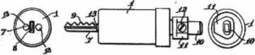

This secrecy has actually been a problem since this information has been available on the web. It has been a problem because locksmiths who are not familiar with the technique don’t believe it can work. Some of those locksmiths have been vocal about their disbelief and even tried to demonstrate that it doesn’t work. It is a shame that the inability of some in our trade reflects badly on all locksmiths. It reflects badly because when the public can see videos on the web and their local TV demonstrating that it does in fact work we lose credibility.

For those who may not know, in 1925 George Baron was granted British Patent 251,810 for Bump Key Technology. He made Bump Keys as a kit which was sold to the trade. Over the intervening years the technique has been forgotten and rediscov­ered many times, most likely due to the secret nature given to it by locksmiths.

There have been a number of patents granted in the US and else­where through the years for methods to prevent bumping. Some of those methods added some significant complexity to the inline pin tumbler mechanism and many of them just simply didn’t work in real life.

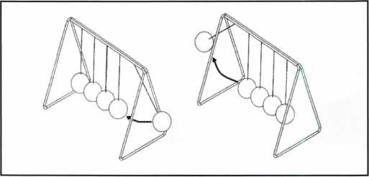

The action of the bump key has typically been thought to repli-  
cate the effect of a pick gun or be similar to the executive desk  
toy shown above. However, we thought that we needed to know  
for sure so we arranged for high speed photography which shows  
that there is a different effect. When used as designed a pick gun  
applies force to the bottom pin and that force is transferred to

the top pin which then  
travels above the  
shear line.

The bump key impacts the bottom pin and then, via the ramp formed by the steeple between cuts, pushes the entire pin stack vio­lently upward. When the pin stack reaches the zenith of its rise in the chamber the bot­tom pin descends and separates from the top pin before the top pin starts to descend. The gap between the two pins crosses the shear line and the slight torque being applied to the key causes the plug to rotate.

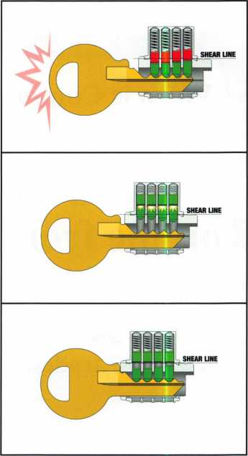

Keynotes • June 2007

**SAFES MANUFACTURER**

We sell directly to locksmiths - no middle man  
Most competetive pricing in the market  
Special incentive for new dealers  
Free freight available on East Coast*

Call us at 877-PROMET1 or 860-436-6246 Download our catalog from [www.promet-safe.com](http://www.promet-safe.com) Visit us at ALOA’07 Show, booth #143

* - subject to conditions

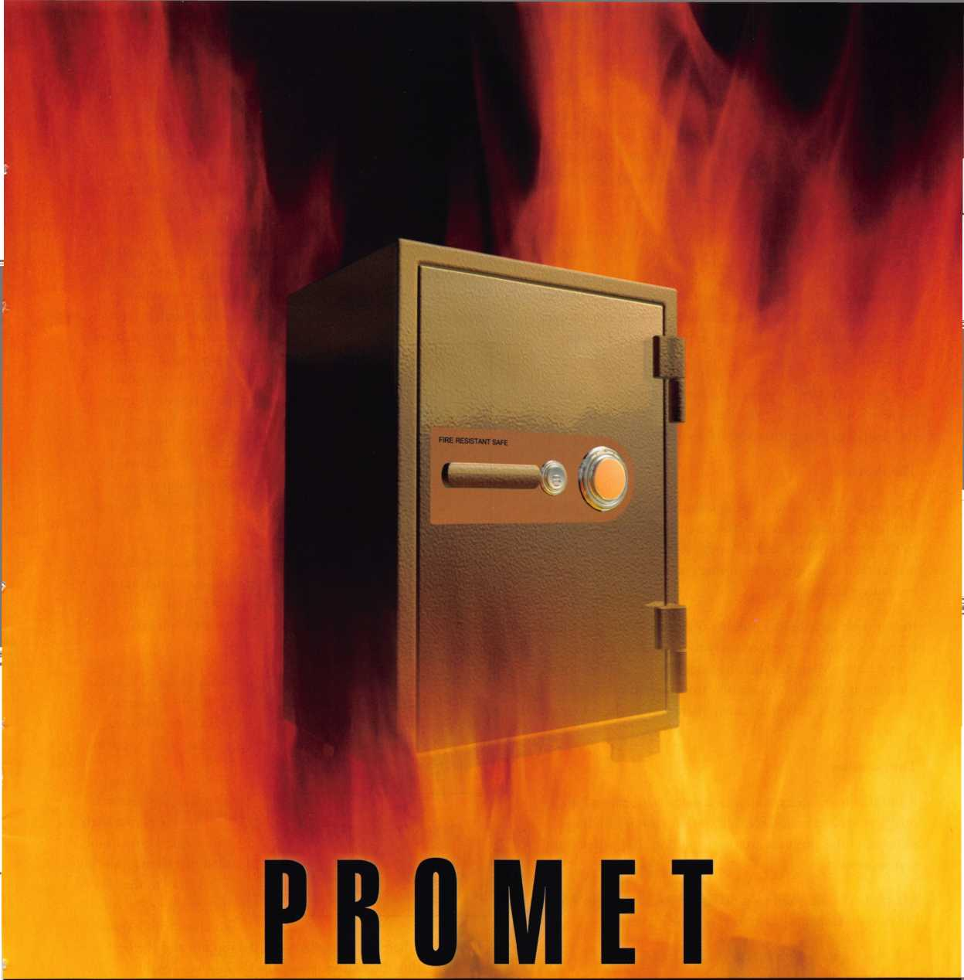

There are two different meth-  
ods that can be used to make  
bump keys and the keys  
produced are used in different  
ways. For lack of better names  
I call the two types of keys  
the PULL type and the  
PUSH type.

The Pull type has every cut  
position cut to the deepest  
possible depth of cut and

then another cut added at the tip of the key with the correct  
spacing as if there were an extra chamber. These cuts should  
be between .005” and .010” deeper than standard for an  
optimal effect.

The Push type key has every possible cut position cut to the deepest possible depth, (plus that .005” or .010” extra), and then the shoulder(s) are cut back .040” to.060”.

The Problem

The problem of course is the significant compromise potential this type of attack presents. Now that the technique is available to the general public, and given the very short learning curve to master the technique, every in-line pin tumbler lock is at risk of immediate compromise.

In fact there have been a number of burglaries around the coun­try with no forcible signs of entry that could be attributed to Bump Keys. Many say that they aren’t being used and, until someone is caught in the act or a true method of determining forensically they have been used, many won’t believe they are a threat.

The Solution

All of that hasn’t deterred the lock manufacturers and many others who have been feverishly working toward finding a solution to this problem attack. A solution that will prevent it from working.

Master Lock embarked on a dedicated R&D effort in August, 2006 to develop a solution to meet three criteria:

1. Cylinder must retrofit into existing locks
2. Highly resistant to bump attacks
3. Cost effective

Our initial development was based on the inertia cradle model. We geared our solution toward that method of attack. The first thing we tried was a telescoping top pin. We even tried a couple of different designs for that pin. They didn’t work! We thought it was the result of insufficient mass in the pin. It wasn’t. We tried the second design for a telescoping pin hoping to equalize the

mass in the halves. That didn’t  
work either. The high speed  
video showed that the pin did-  
n’t telescope at all because the  
action did not replicate what  
goes on in the inertia cradle.

Then it was on to other ideas.  
Magnetic pins were next. In  
theory a magnetic top pin with  
a steel bottom pin should be

inseparable. They weren’t! In all cylinders there is a shelf created  
between the pin chamber in the shell and the corresponding  
chamber in the plug because the chamber in the shell is typically

larger to allow for some small  
end play that occurs in all  
cylinders. On the way back  
down the magnet isn’t perfectly  
in line with the bottom pin  
and the edge of it hangs on  
that shelf. The extra mass in  
the steel bottom pin causes  
them to separate and the lock  
is bumped open.

Spool pins and using stronger springs were ineffective too.

We also thought our EDGEc key control product could resist  
bumping. If the dimple pattern wasn't correct it was bump  
proof, but if you have the correct dimple pattern you can  
eventually bump it.

Due to our lack of success we commissioned high speed video  
(2,162 frames per second) to better understand the dynamics  
of the lock bumping technique. After analyzing the video we  
changed design direction based on learning what really happens  
in the cylinder.

The first new idea was  
the shouldered pin with  
an oversized bore in the  
shell that didn’t quite go  
all the way to the ID of  
the plug hole. In con-  
junction with a short

bottom pin there was a gap between the top pin and the bottom  
pin. Impacting the bottom pins with a bump key wouldn’t cause

the bottom pin to move the  
shouldered pin. Eureka! It  
worked. A cylinder that was  
roughly 90% bump resistant.

Now it was time to improve  
the result. Changing the  
shape of the top pin so that

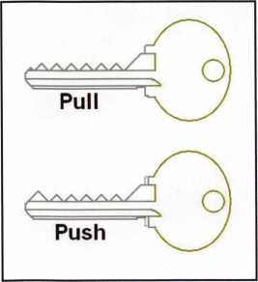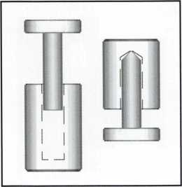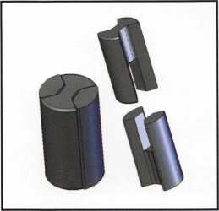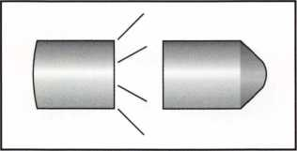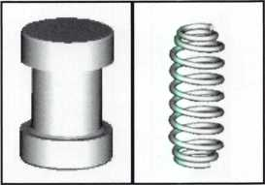

Keynotes • June 2007

See your authorized  
Bianchi distributor  
for details!

Repli-Code7TX

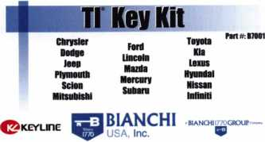

[www.blaiichi1770usa.ceni](http://www.blaiichi1770usa.ceni) tnto«WancW1770usaconi BOO 891 2118 210-8034202 la*

|  |  |  |  |  |
| --- | --- | --- | --- | --- |
| w  ITEMFOi  i  BT*30f0B | y  BB72U IT! | u  MU BTITB3U | u  HHTW | V  vl |
| u | Vi | u | u | 3  um  - |
|  |  | / w |  | 3— |
| irn«M | ■TIT WO MU |  | IMMI | imsm |

Tl Key Kit  
(B7001)

|  |  |
| --- | --- |
| d | j |
| | Clonable Transponder Key Kit |
| i 9 _ j | Port #: B7002  General Motors Mazda  Porsche Nissan/lntiniti  Dodge Honda  Cadillac Chevrolet  Bulck Oldsmoblle  Saturn Pontiac  biancmi770usa com hrt»att»cftiiTn)tts*.coni 800-891-2118 216 803-0202-la* |
|  | |

|  |  |  |  |  |  |
| --- | --- | --- | --- | --- | --- |
| 6  BHU66T5 | a | ■asms | 9  Biwm | 1 i | 9  inewra |
| 6  I  BIVB6T7 | 9  IKOIBUPTb |  |  | 8 |  |

Clonable Transponder Key Kit

(B7002)

**Program 75%* of transponder vehicles on the road  
with the Repli-Code 7 TX Bundle Pack**

**a BIANCHI I770GROUP** Company

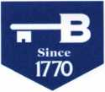

**BIANCHI'**

USA, Inc.

800.891.2118

[www.bianchil770usa.com](http://www.bianchil770usa.com)

Estimated amount

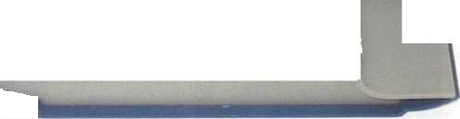

it had a taper proved to be about 97%  
resistant until 20 hits or so had been tried.  
It had the added benefit of being more  
economical to produce since counter  
drilling wasn’t involved. Then the pin  
chamber started being distorted and the  
pin no longer wedged itself in place. The  
top of the chamber actually becomes  
beveled to match the pin shape and then it

bumps much easier as well as letting simple torque sometimes  
cam the pin out of the plug.

Time to change design. The solution  
was to reverse the taper on the end of  
the pin. The oversized tumbler diame-  
ter serves to keep the pin from fully  
entering the plug and the reverse taper  
also has the effect of improving stan-  
dard pick resistance, increasing the  
bump resistance to 99.99% and mak-  
ing bump attempts fully detectable.

Thus, the Master Lock Bump Stop  
technology became a reality. With this  
result, our objective was achieved.

The solution will be available as an

option in keyed locks and cylinders. Pins will not be made  
available as a service part as they are only a component of the  
overall solution.

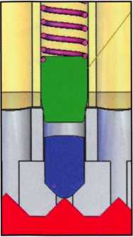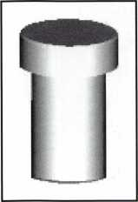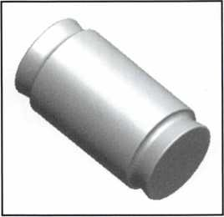

pin starts to mark the plug with the first impact, easily detectable with micro­scopic analysis.

The sequence here reflects  
what happens inside the  
cylinder equipped with this  
pin when it is bumped.  
Notice that the new pin isn’t  
moved in the bump process.  
This new pin design only  
needs to be in a single pin  
chamber to make the lock  
very bump resistant. That  
one location needs to be in  
the same chamber as a 0, 1  
or 2 depth in Master Lock  
Padlocks or a 1, 2 or 3 in  
American Lock padlocks.

Master Lock has applied for  
patent protection on this new  
technology and will be mak-

ing it available for use in all in-line pin tumbler products from  
padlocks to door locks. Initial padlock production will begin in  
June and will be available in the entire product line by October,  
2007. Contact your distributor _ the Bump Stops here!

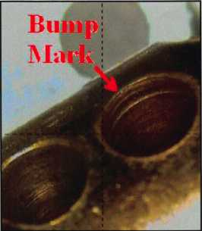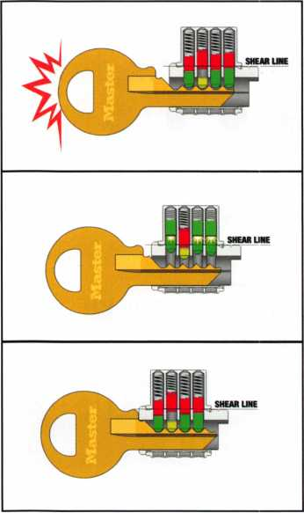

Now let’s take a  
look at that  
detectability factor  
offered by the new  
pin. By design we  
made the corner of  
the pin a sharp one  
and because the pin  
has very little side  
to side movement,  
when the lock is  
bumped the pin  
actually starts to  
serrate the inside of  
the pin chamber in  
the plug. This  
photo is slightly  
exaggerated because  
this lock had been  
bumped around  
130 times without  
opening, but the



Keynotes • June 2007

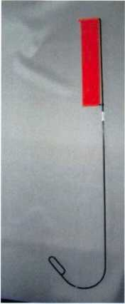

Emergency Door Opening Tool

AS SEEN AT THE 2006 A.L.O.A CONVENTION

All commercial buildings have two things in common:

* Fire code requires that all commercial locks open by a single action.
* The American Disability Act requires free access through doorways,  
  which leaves a gap between the door and the floor.

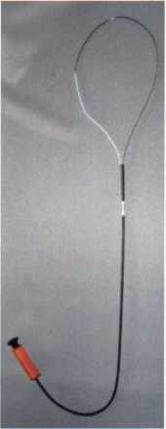

Knoblock Tool

Leverlock Tool

WITH THIS IN MIND WE HAVE DEVELOPED THE TOOLS REQUIRED TO EFFECTIVELY  
OPEN DOORS QUICKLY AND WITHOUT DAMAGE

Designed for interior commercial doors

For knoblocks, the tool is slid under the door with no cords to pull or get tangled.

For leverlocks, a similar tool is used by applying the same method of sliding the tool under the door and pull until the lever retracts.

Both tools are designed to work with very little effort, excessive force is not needed.

Visit our web site at [WWW.THEBEN-JIM.COM](http://WWW.THEBEN-JIM.COM) for more details.

THE BEN-JIM KNOBLOCK TOOL $ 99.00

THE BEN-JIM LEVERLOCK TOOL $ 79.00

SET (one each) $ 169.00

PLUS SHIPPING & HANDLING

**TO PLACE AN ORDER CALL 1-586-778-1911 OR VISIT US AT [WWW.THEBEN-JIM.COM](http://WWW.THEBEN-JIM.COM)**

MADE IN THE U.S.A BY THE BEN-JIM CORPORATION.

24711 Harper Ave. * St. Clair Shores * MI * 48080 * (Fax) 586-778-0530



Welcome to our new monthly feature! Each month we will highlight a current ALOA mem-  
ber & their lockshop with a short bio and in-depth questions. To be considered or to recom-  
mend a fellow ALOA member please read the information provided at the end of this article.

ans Mejlshede, CML has been  
a member of ALOA since 1974  
and started his interest in lock-  
smithing in the early fifties.

Mejlshede Laase/Nogler AS  
Noerrebrogade 84  
Copenhagen N, Denmark DK 2200  
011-453-5393939



1. Tell us about your background in security and your experience in locksmithing.

Hans: As a child, I was a regular visitor in my uncle and dads locksmith company.  
As long as I can remember, I have been around locks. It was learning by doing for all  
of us in those days. While earning a Master’s Degree in Mechanical Engineering, I  
would do administrative work and locksmithing jobs in the evenings. In 1970, I  
became a full time locksmith.

1. How long have you been a member of ALOA?

Hans: My membership at ALOA started at the 1974 Boston convention, and I have  
attended every ALOA conventions since that time.

**16**

Keynotes • June 2007



Start Your Engines!

This year, with a great location and a  
schedule chock-full of exciting classes  
and events, we are pulling out all the  
stops to celebrate the ALOA Convention  
and Security Expo in Charlotte, North  
Carolina.

Having built an international reputation  
among locksmiths as a powerful resource  
to explore industry innovation and form  
industry alliances, ALOA 2007 is the ideal  
place to learn, network or to showcase  
your security-related business on the  
show floor.

This year weve thought of everything  
from an exciting location to a comfort-  
able hotel and a convention center that is  
equipped to handle your every need. The  
exhibit hall promises to be overflowing  
with the latest technology and new mer-  
chandise.

july 22-29, 2007

charlotte, north Carolina

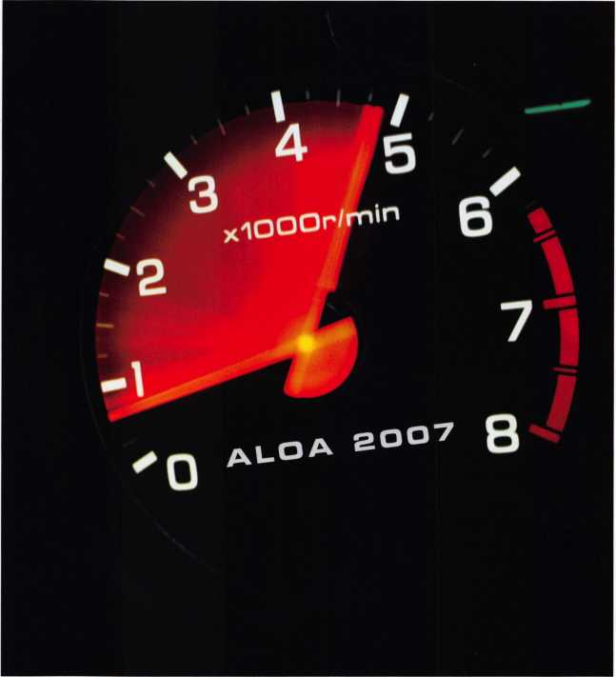

aloa convention and security expo

*51****st ANNUAL***

Don't miss out

’ I

3. How long have you  
had your business?

Hans: My father and I  
started a locksmith  
business together in  
1964.

1. What was your starting point in security?

Hans: My starting point was clearly my uncle and dad’s lock­smith company in the early fifties.

1. How many employees does your business have?

Hans: We are around 50 employees. One reason for the size is that, in the past few years we have bought 2 medium sized companies where there was a problem with the generation change-over.

1. What are the changes that you’ve noticed in the security technology recently?

Hans: We do a lot of access control systems, and we cable less to day because we connect to the computer network. The TCP/IP numbers are the important things to day.

1. What do you see as the future of security and where do you think are we headed in today’s age of technology?

Hans: There will be more and more electronic solutions in the future of security. Most of these will be complex and complicated. The locksmith companies that master these solutions will be the winners in the future. There will be little competitions from chain stores, like Home Depot, because they probably won’t have the staff to handle complicated elec­tronic solutions.

1. How do you stay informed about new products and secu­rity techniques? i.e. magazines, conventions, classes, etc.

Hans: I stay informed in a number of different ways. I read most of the locksmith magazines. I attend several conven­tions a year in the USA and in Europe. I also find that, as an instructor, I learn a lot from the members who take my class­es.

1. Do you find that other locksmiths in the Denmark area work together on referrals and work flow?

Hans: Yes a lot. We are more specialized to day than we were 10 years ago. We do not do automotive work; we refer it to someone who is specialized in that field. If one of our bigger accounts has a minor job 200 miles away, most likely we will use a local locksmith as sub-contractor. We specialize in safe work, because we have most of the necessary expensive tools and knowledge, so we do quite a lot of sub-contracting for other locksmiths.

1. Is there any noticeable difference between an international locksmith and those here in the U.S.?

Hans: There are several. We have very few in-house lock­smiths, it is all out-sourced to local locksmith companies. On a technical level, master keying is done very differently. We are not good at impressioning but that may be because all automotive key blanks in Denmark are steel.

1. How has life changed for you as a security professional in the past year?

Hans: It was worrying to see the ASSA ABLOY group buy 3 large locksmith companies in Denmark. Now you have to compete against your own supplier. We do not see this as the best solutions, we would have preferred a private ownership.

1. How do you sell security to the public?

Hans: We have a comprehensive marketing program, two shops and two full time sales employees.

1. Explain what your position is at your business.

Hans: I am the owner and manager, but all important deci­sion are made by the whole family. That is my two sons, my wife and me. It happens that I am “Voted” down at times!

**8**

Keynotes • June 2007

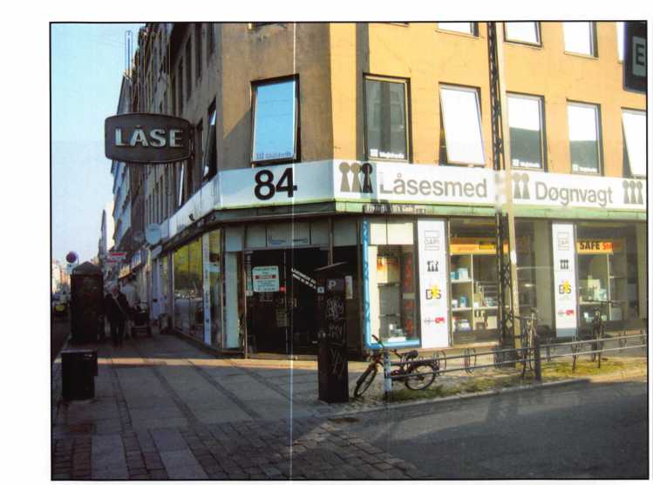

**DEALERS & DISTRIBUTORS**

REQUIRED

£. M l

-~pe^

• ; i » -

INKAS

Call Today For Available Territories

(877) 913-7233

[www.inkas](http://www.inkas). ca

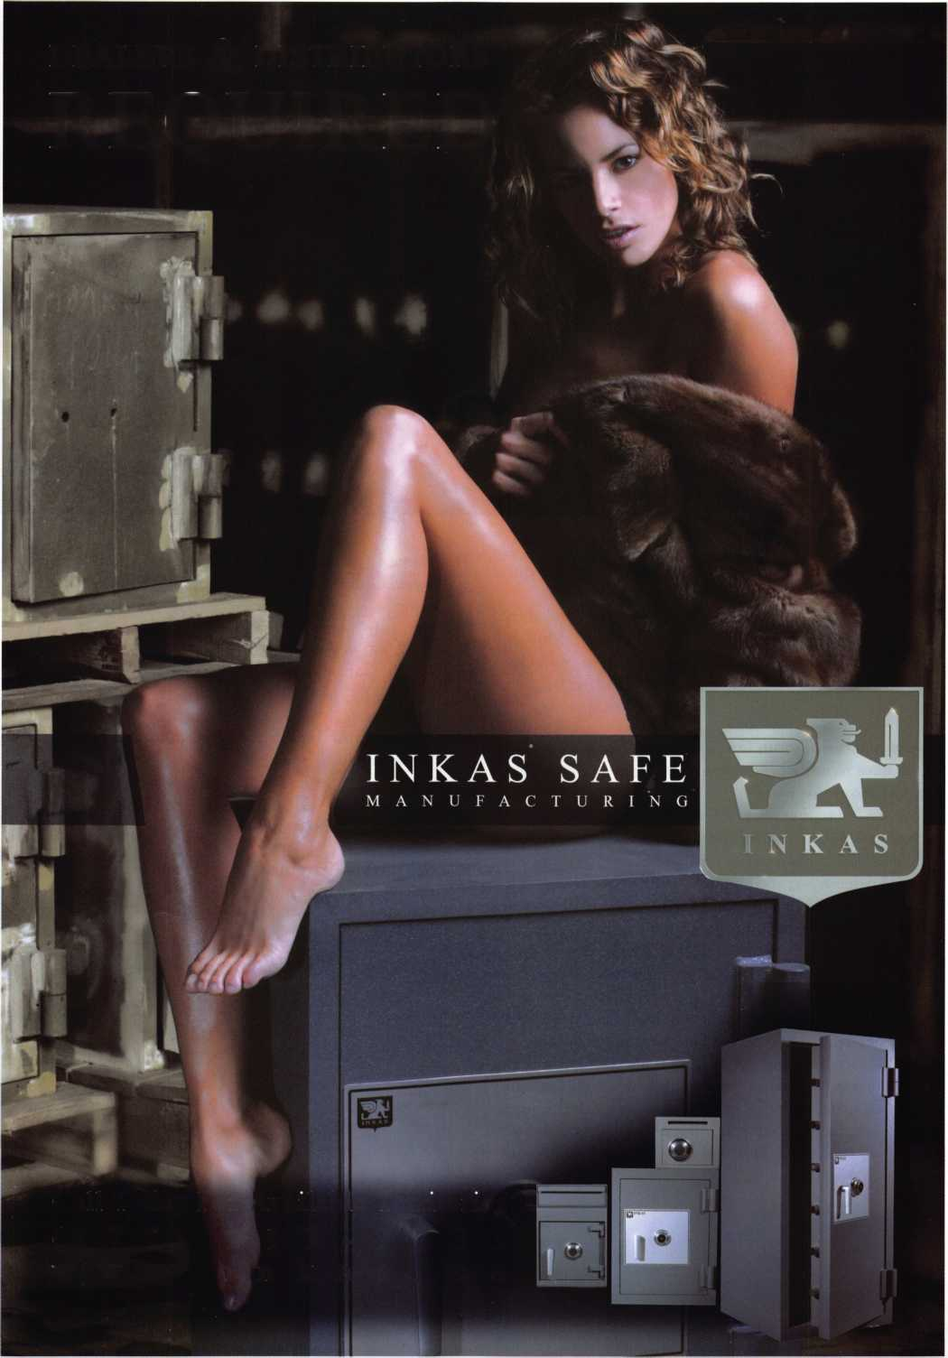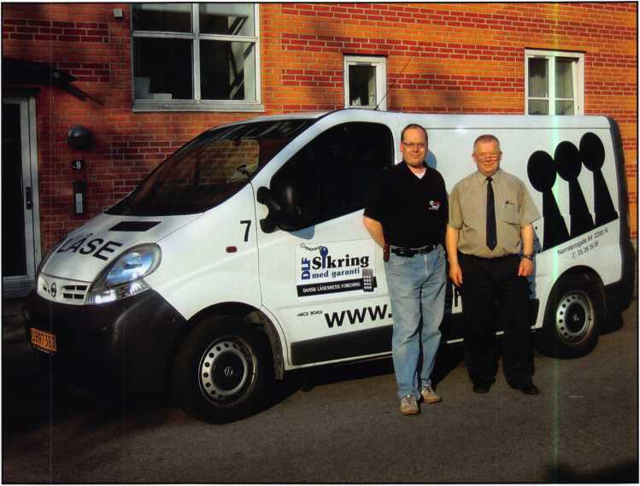

1. What do you like most about  
   your job?

Hans: All of it! The variety in  
our daily life, the many technical  
demanding jobs, the good rela-  
tions with employees and cus-  
tomers, and meeting many very  
interesting people.

1. What advice can you give to  
   an aspiring security profes  
   sional?

Hans: Take as much education  
as you can. Be a member of all  
relevant associations. Try to cre-  
ate a network of trustworthy col-  
leagues. Subscribe to most of  
the security magazines. Attend  
local and national conventions.

Do not expect anything less than  
a 60 hour working week. Doing  
this you will, after a few years,  
be the perfect locksmith with a  
pleasant annual income.

1. Can you remember your first big security job? What can you tell us about it?

Hans: Yes I can! We sold a big Medeco system to one of the telecom companies in Denmark: 12000 cylinders, 15000 keys. We won the bid with a few thousand dollars, we were lucky! That gave us a very good reference that later helped us land other orders. We are still maintaining this system to-day.

1. Have you personally run into issues with bump keys which have recently been featured in the news? How do you feel about this issue?

Hans: An interesting story in Denmark! In October 2006, we had a 40 minute consumer program on one of our main TV channels. It turned out to be the most seen program that week. The theme was the insurance companies refusing to pay if there was no sign of forced entry and forgetting to tell that it might be possible to make a forensic examination to see if a bump key or other picking tools had been used. In the program, I was able to prove that locks in an insurance case, where payment was denied, had been opened with a bump key. At the end of the program, high security cylinders were recommended to solve the bump key problem. The result was overwhelming! All high security cylinders on the Danish market was sold in two days! It affected all locksmiths in Denmark, and even to-day, half a year later, our customers at the counter ask for bump key resistant cylinders. All this done, I still believe it is unethical to publish picking instruc­tions to the general public.

1. Name a few things that you think locksmith business owners should do to help their businesses prosper and grow.

Hans: If you have a good marketing programme, give an excellent service and have a friendly relation with your cus­tomers, you will prosper and grow. You do not need to be the cheapest locksmith in town.

1. What do you think is the biggest obstacle facing security professionals, if any?

Hans: I believe that security professionals who understand that learning is a life-long process, will have fewer problems in life and in their profession.

1. What is your favorite place in Denmark?

Hans: The Tivoli amusement park in the center of Copenhagen! Nice flowers, pleasant live music and good food! Come and see for yourself.



Keynotes • June 2007

Go National, or Go Home?

What to do about Vendor Consolidation

“Sorry, the service contract is handled by corporate on a national level.” This is a common response that locksmiths and other local service com­panies are hearing at an increasing rate from their commercial prospects and clients. The reason? Vendor consolidation.

Facility management is becoming a much more sophisticated and scruti­nized area for national corporations. When it comes to cutting costs and meeting budgets, building operations is regularly the first item to which management will look. The answer to cut costs? Vendor consolidation.

Corporate America has long understood the economic efficiencies associ­ated with consolidation. The proper merging/acquiring of companies allows national organizations to increase margin, expand into new indus­tries and markets, and take out the competition.

Within the last 5-10 years, facility and property managers have started utilizing a similar consolidation strategy for the selection and use of ven­dor/suppliers. By outsourcing maintenance/repair services to one or a very few national service companies, the property manager is expecting greater savings through consistent service levels, less vendor manage­ment, and less invoice/accounting costs.

What does this vendor consolidation trend mean for a local, specialized service company like a locksmith? For some it may mean less opportuni­ty and thus less revenue from larger, commercial customers. In response, service companies are beginning to look at different options to counter this growing threat to their commercial revenue caused by vendor con­solidation. The following are a few options, with strengths and weak­nesses of each, which service companies are considering:

* Increase residential focus
* Strengths: immediate payment, extra “emergency” charges
* Weaknesses: less loyalty, less regularity of service needed
* Have a “local” only focus
* Strengths: more personal sales relationships, less vendor consolidation
* Weaknesses: limit revenue/growth opportunities
* Join national franchise
* Strengths: national recognition/power, operation support systems
* Weaknesses: high fees, limited flexibility
* Perform subcontract work
* Strengths: additional revenue source, little sales/marketing required
* Weaknesses: lower margins, easily replaced

• Join national consortium

* Strengths: national power, low fees, maintain independence/flexibility
* Weaknesses: limited training, limited central control The Symbiot Solution

The group of founders and investors of Symbiot, a nationwide facility/property service company, recognized the beginning stages of vendor consolidation early on. Founder and Symbiot Chairman Steven Glover experienced firsthand the negative effects of vendor consolidation for his multi-million, multi-branch service company in northern California. “We were one of the largest and most well respected compa­nies in our industry and in our area. Our customers enjoyed the service we gave them, but we could not come anywhere close to expanding fast enough for some of them. We lost a few of our key contracts because of our inability to go national.” Each Symbiot founder and investor experi­enced the consolidation phenomena in different ways, from Steven Glovers challenge to current Symbiot CEO and former global facility manager, Mike Edwards, who believed that vendor consolidation was not happening fast enough and that there was no adequate organization that he could turn to.

Symbiot s unique property service model has been able to satisfy the national property managers and owners’ needs by creating a platform that utilizes top-tier local and specialized companies for the service needs of large, national accounts that it manages. Symbiot s current service offerings include locksmith service, pest management, landscaping, plumbing, HVAC, electrical, snow removal, janitorial, parking lot main­tenance, and other repair/maintenance services.

Companies that join Symbiot s service network are not asked to change their name, uniforms, or operational structures. However, service com­panies must go through a screening process before admittance into the Symbiot network to ensure that insurance, service quality, and profes­sional standards are met. In addition to the application process, a small annual fee (about $500) is required to join, which provides access to more than just national contract work. Symbiot has created purchasing programs and holds regular training meetings that network companies have access to. Symbiot is now entering into its eighth year of providing customers with the best of both worlds - a simple one vendor, national service solution with local commitment.

21

Keynotes • June 2007

Mother Nature Meet SureStrike

Locksmiths now have a weapon to battle an age-old problem.

One thing we all know is that soil shifts. Whether from severe conditions such as drought, flooding, earthquakes, soil erosion, or just normal seasonal changes, the outcome is that foundations and doorframes will shift. As a result, the deadbolt locks we rely on to keep our families and per­sonal property safe are compromised.

Locksmiths have been waiting a lifetime for a product to revolutionize the striker plate. WMW Innovation Company has answered the call. With the introduction of the Sure-Strike striker plate with patent pending design technology, locksmiths and homeowners are in a win-win situation. The innovative design addresses the need for a stronger striker plate, but also one that incorporates adjustability in order to deal with the shifting soil and weather that causes the misalignment of deadbolts. This unique formula sets the Sure-Strike product in a class by itself. This is good news for the locksmith who now can spend more time installing a quality product that meets the homeowners needs, and less time adjusting and read­justing striker plates to accommodate the whims of Mother Nature.

And just when Mother Nature is satisfied, the news media floods us with headlines that disrupt our sense of security. Our homes should be our safe havens, but statistics tell us otherwise. In less than one minute, and with three kicks, an average residential entry door with a deadbolt lock is open. Five minutes later, our personal property is gone. Sure-Strike is striking back. It is specially designed to resist kick-in burglaries, which account for a large percentage of home invasions. With 2.9 million homes burglarized last year, and losses estimated in the billions, the need for a

product like Sure-Strike is enormous. It has been tagged “the most innovative striker plate since the striker plate itself,” and it lives up to the billing.

Locksmiths have been provided a captive audience. The additional reasons to sell and install Sure-Strike are many:

* Locksmith distributors will stock Sure-Strike for exclusive purchase. It will not be available at large home improvement centers.
* Sales will be jump-started adding profits to the bottom line.
* No product competition. Sure-Strike is one of a kind.
* Innovative design incorporates space-age composites and stainless steel. The effect _ the weakest part of the door environment now becomes the strongest; and it can handle all sorts of weather.
* The adjustability feature compensates for soil movement, eliminating misalignment issues, making deadbolts easy to use by everyone.
* 3 1/2 inch screws add protection and connection to the door/house framing.
* Installation is simple.
* Affordable cost.
* Compatible with all deadbolts.
* Restores tranquility to victims of home invasions with kick-in resistant reliability.

22

Keynotes • June 2007

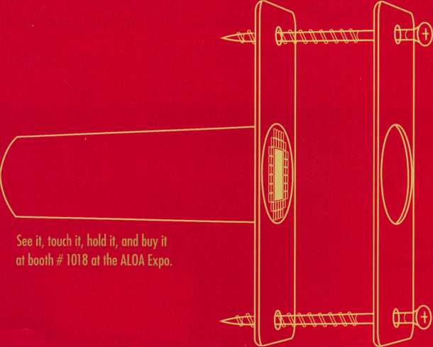

**The much anticipated Sure-Strike™ is here. Unlike any striker plate you've ever seen for exterior doors. Its patent pending design  
not only self-adjusts to misaligned deadbolts due to shifting doors, it also resists kick-ins, sawing, and prying by would-be burglars...  
making it truly the most innovative striker plate ever built. And better yet, it's only available to the public through you - the locksmith  
Now you've got something to sell that those big home improvement stores only wish they had. To find out how your business, and  
your customers, can benefit from the new, innovative Sure-Strike give us a call or visit us on the web and put it on your wish list.**

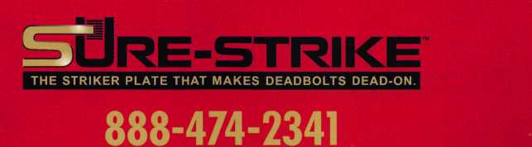

[www.sure-strike.com](http://www.sure-strike.com)

**Sure-Strike is a product of WMW Innovation Co. ©2007**

“Do the math,” said Everett Wilder, VP of Advertising at WMW Innovation Company, “An average home has three exterior doors waiting for this product. How many homes in your neck-of-the-woods would benefit from this prod­uct? Answer that and then multiply by three.” The Sure- Strike system will increase profits.

The Sure-Strike prototype was first introduced at last year’s A.L.O.A. trade show in Las Vegas and was met with rave reviews. “We were there to gauge the industry’s interest, and to hear design, price, and installation recommenda­tions from the target audience _ the locksmiths,” said Winston Wilder of WMW Innovation Company. The results are a stronger Sure-Strike system, one that is easier to install and will be cost effective for both locksmiths and consumers. This heralded product will be ready for pur­chase at the upcoming A.L.O.A. trade show in North Carolina in July.

Scott Meyer, President of WMW Innovation Company, said, “We are on a mission to provide locksmiths with a product that is so effective in addressing one of their biggest and most time-consuming issues, misalignments, that it all but eliminates the problem. We also want to provide the homeowner with a security feature that adds protection to their homes.”

“Sure-Strike provides peace of mind when the doors to the outside world are closed and the deadbolt is fully engaged,” say Larry Larson and Bob O’Neil, owners of M2M, the marketing firm hired by WMW Innovation Company to promote the revolutionary Sure-Strike.

A striker plate that self-adjusts and resists kick-ins? The folks at Sure-Strike might just have their hands full keeping up with orders. Mother Nature: Look out. Burglars: Don’t go there.

Need information in a hurry?  
Use ALOA’s Fax On Demand se

service

L1JL£JL2J

**lzjudll)**

updbGD

Just call 310-575-5027 and receive:

1. ALOA Index of Documents (1 pg)
2. Reasons to Join ALOA (2 pg)
3. Locksmith Career Summary (3 pgs)
4. Locksmith School List (1 pg)
5. ACE Class Schedule (1 pg)
6. Certification Information (5 pgs)
7. PRP Category List (1 pg)
8. ALOA Membership Application (1 pg)
9. ALOA List of Benefits (1 pg)
10. ASF Scholarship Application (1 pg)
11. ASF Scholarship Information (1 pg)
12. ALOA Video Library Order Form (1 pg)
13. Safe & Vault Technicians Association Membership

Application/Subscription Form (2 pgs)

1. Recertification Information (4 pgs)
2. Legislation Action Network Newsletter (2 pgs)
3. Various State Law Issues (8 pgs)
4. Industry Position Paper (1 pg)
5. ALOA Convention Class Schedule (3 pgs)
6. ALOA Convention Class Descriptions (30 pgs)
7. ALOA Convention Registration Forms (4 pgs)
8. Board of Directors Nomination Form (2 pgs)
9. ALOA Company Membership Application (2 pgs)

Keynotes • June 2007

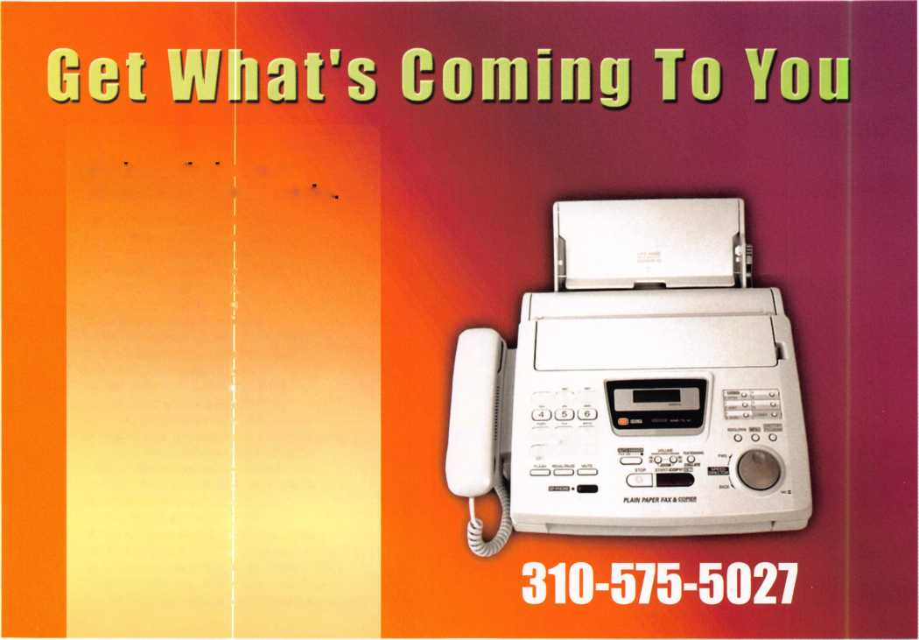

**• Weslock**

Stocking these manufacturers and more:

* **Baldwin • Kaba • Monarch • Von Duprin**
* **Falcon • Kwikset • Rocky Mtn. • Welser Lock**

**Pennsylvania 1-800-233-4210 Fax: 1-800-854-4146**

**Nevada**

**1-800-722-4210 Fax: 1-800-248-3620**

**Midwest Missouri 1-800-211-4607 Fax: 1-800-211-4608**

**[www.topnotch.bz](http://www.topnotch.bz)**

**[sales@topnotch.bz](mailto:sales@topnotch.bz)**

Over the Top -

**rain or shine, Top Notch  
always delivers!**

**Distributors of Architectural Hardware Products**

We Know Service knows no boundaries!

Even in the midst of a natural disaster, like the recent flooding of our Honesdale, Pa. warehouse, Top Notch has the resources and ability to get the job done. Customer calls were seamlessly rerouted to our Missouri and Nevada locations. Our acclaimed customer service and dependable delivery never skipped a beat.

Here are just a few more reasons why Top Notch should be your first choice for Architectural Hardware products:

* Extensive selection of architectural styles and finishes
* Products in stock and ready for immediate shipment
* 99%+ order accuracy rate
* Knowledgeable staff averaging 15+ years of experience

Together, our people, our products and our ability to get  
the job done exemplify ... We Know Service.

Top Notch Distributors. Inc

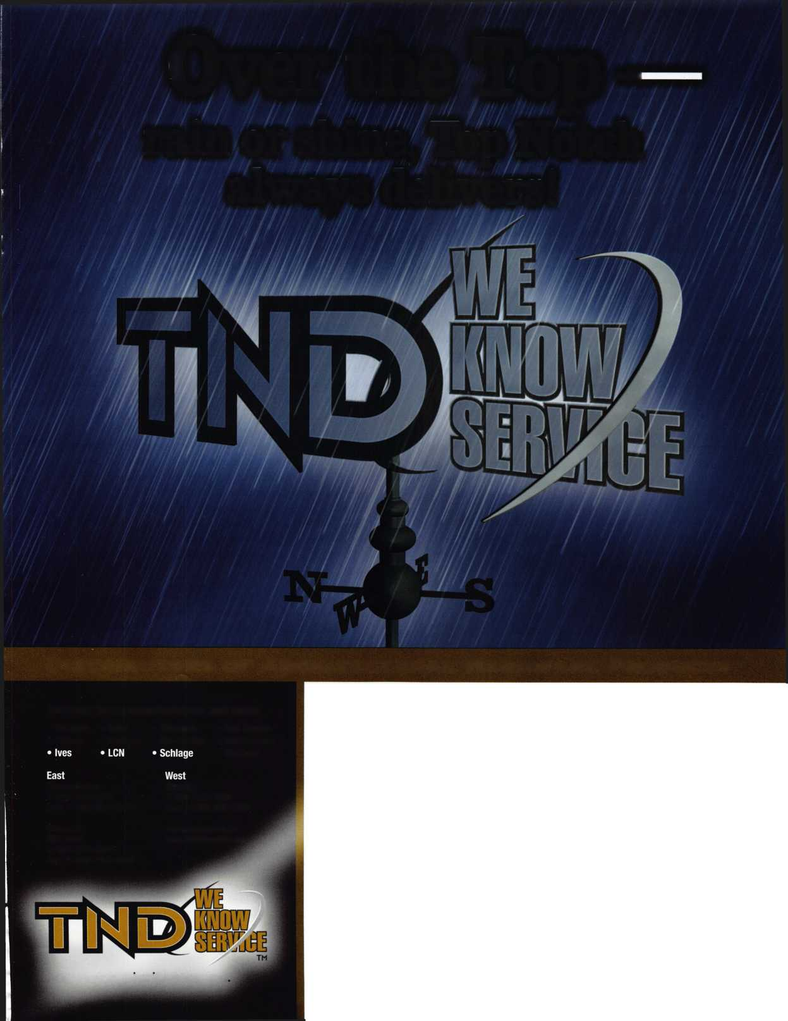

Humor and Other Things in the Service Business

By C.D. Lipscomb, CML,CPS,CIL

After a lifetime of being in the service business, I have found more than enough experiences to keep you either crying or laughing for days.

Since crying is so stressful and more people care to laugh with you than commiserate, I mostly choose to remember the funny things that have happened during my career. I have included a few of them here.

The Midnight Call

About 10 years ago, I got a call from a nervous-sounding young lady asking me to help her get her keys from inside her car. She asked me to come to a farmhouse in the country and pick her up. She then directed me to drive yet another 3 miles down a lonely, deserted dirt road. There, we found her car parked in the middle of the road.

It was an eerie sight with no moonlight and only my headlights and my flashlight to see by. There were bushes and trees growing alongside the road and the young lady was a bit short on details about how the car came to be there. Usually, a customer will go on and on about how they locked their keys inside. This time, my customer was unusually quiet. When I asked, she timidly said that the keys "were on the front seat". I shined my light on the front seat of her car and the keys were there. Indeed, they were sitting on the front seat, on top of a neatly-folded pair of men's pants and briefs. I asked, "Where is the owner of these pants"? Right then, an exasperated young man's voice came from the bushes at the side of the road telling me to "mind my own business, and just open the damn car!"

Now, I have never named names but I have told this story often and had a good laugh each time. I actually use this in my car opening-spiel to comfort distraught female lockout customers. I tell them that most of my lockouts are indeed ladies, but it is not really a gender thing, but more about the convention of dress. A lady puts her keys in her purse (along with the other three sets) and leaves the purse sitting on the front seat of the car. However, a man puts his keys in his pants pocket and rarely leaves his pants in the car..But there was this one time...

The Doctor is IN

A few years ago, I got a call from a medical clinic. The problem was an exam-room door that suddenly would not open. The nurse that called said that some people were locked in the room and it was “kind of an emergency”. Fifteen minutes later I was in front of the door with my tool kit. It turned out to be a broken and jammed latchbolt.

The door led to a small exam room and a doctor and his patient were locked inside. It seems that they had been there over a half hour prior to calling me. Broken as it was, there was no way to budge the latch or to open the in-swinging door without doing major damage to an expen­sive door and frame. As I worked, I would periodically hear someone inside say “Jeeze, Doc, I am sorry about that”. A few minutes later, I would hear the same thing, “Jeeze, Doc. I am sure sorry about that”. Each time, the older nurse who had called me just cracked up laughing.

I got to wondering just how warped her sense of humor was. She proba­bly enjoyed going to funerals, too. From listening and talking to the doctor, I could tell that he was highly agitated. Again, I heard, “Jeeze, Doc. I am so sorry about that.” I was thinking that this guy must have

broken the door and was feeling guilty. The nurse just cackled, but said “Never mind me, just go on.”

I determined that the best and least-destructive method of entry would be to slide a flat bar under the door and get the doctor to raise the hinge pins out and then push the door in. This would save the door and the lock. The doctor hollared “Bust this door down and get me out!” He sounded really irritated. Again, came the mournful apology,“Jeeze, Doc.

I didn’t mean to do that”. I tried to direct the doctor on how best to remove the hinge pins and he completely lost it. “Break this door down and just get me the Hell out of Here!!!”, he screamed at the top of his voice. His nurse was having a hard time standing up holding her sides from laughing so hard. Gosh, what a mean woman she was. No way was she going to be at my next physical. All this time, it was getting monotonous and irritating to hear the poor guy inside beg forgiveness.

The doctor was steadily losing it. I was afraid that he was claustropho­bic and being locked in that tiny room was making him crazy. I knew that I had to get control of the situation quickly. So taking a deep breath, I gave my best imitation of a drill sargents voice at reveille. At the top of my voice, I yelled “Doctor, Shut your mouth! Get control of yourself, and lets get this done, NOW!” Now anyone that has ever dealt with a doctor before knows that these are take-charge guys with ego big­ger than Dallas and they don’t take any backtalk from anybody. (Hmm, they might make good locksmiths with attitudes like that.) The test of wills continued for a few more harsh words and then the other guy was heard to say, “OH!! That was really bad. Jeeze, I am so sorry, Doc.” Suddenly, the doctor quieted down, and said “Now just what do I have to do?” The nurse was clinging to a chair to stand up and was out of breath from laughing.

With a more docile manner, the doctor inside finally comprehended the necessary instructions on how to remove the hinge pins and by using the little rubber hammer that he uses to test your reflexes, he finally removed the two hinge pins. (If there had been three, we would still have been there.) I said “Stand back now”, and put my shoulder to the door, pushing it inward. The doctor bolted outside the room, climbing over me like a scalded cat, followed closely by a foul brown haze of the most noxious smelling stuff I have ever been exposed to. “Jeeze” the guy in the exam robe said, “I am really so sorry about this.” By now, the nurse had gotten a hold of herself and was trying to wipe the grin from her face. She failed miserably.

As Paul Harvey would say, “The rest of the story is...”. The other occu­pant of that tiny exam room, the person so sincerely apologetic, was a 400 lb. man whose original complaint was acute, chronic, voluminous and unusually aromatic intestinal gas.

The poor doctor s eyes were red and running. Unable to say anything, he made a beeline for the outer door where he stood there taking huge breaths of fresh air and soaking up the purifying sunshine. In a few minutes, he came back and apologized for his loss of composure. He said “You cannot know just how bad my day has been.” Whew!!! After taking a deep breath, I feel that I had a pretty good idea.

Keynotes • June 2007

Real Security Is When Do-Overs  
Take Place Only On Your Personal Time.

When you install Schlage® locks, you know you've done the job right. After all, our products are among the most durable and dependable on the market today. They're also easy to install, repair and maintain, so they generate fewer callbacks. Which means you're free to concentrate on other things. Like learning how to pick up the 7-10 split.

Real Security Sets You Free? £3EEEF

[www.schlage.com](http://www.schlage.com)

*

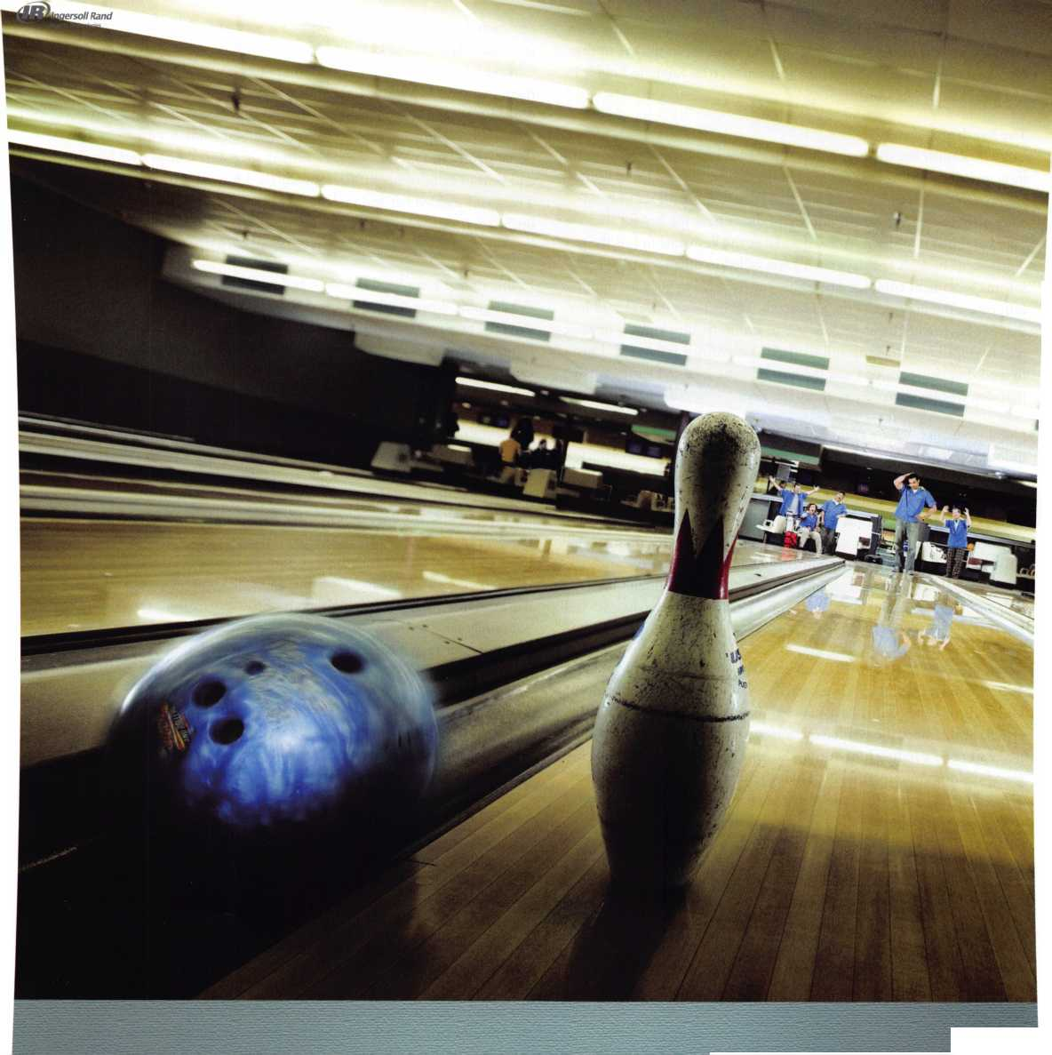

I live and work in a small town and see all of these people around town. Funny, neither the doctor or the patient will look me in the eye to this day. Every time I see the nurse, she just smiles, tries vainly to hold it in, and then just cackles out laughing.

The handcuffs

Every locksmith has some story like this. Once I had a man come to my shop one day wanting keys for a set of handcuffs. He said he had just gotten a job as a security guard and had bought this used set of hand­cuffs without a key. It turned out, that I didn’t have the key for that brand and had to order it. A few days later, the key came in but the guy didn’t come back. A few days later, I was called to do a job at the low- income apartment complex where this guy lived along with his signifi­cant other, the manager of the apartment. While I was there, I told her that her boyfriend’s handcuff keys are in and to let him know. The secre­tary whooped out laughing and the lady’s face turned bright red. I just figured that either she or I was the butt of some joke and let it go. Later that day, he came by and picked up the keys.

Not a week later, I got a night call to come to the apartment to do an unlock. Strangely, I was asked if I could come in an unmarked vehicle. That was a red flag. I arrived at the apartment manager’s room where she and her boyfriend lived. There she was, in all her naked glory, hand­cuffed to the four corners of the bed with a sheet covering her. The boyfriend, who turned out to not be a security guard after all, had got­ten some other handcuffs and immediately put them to use. Unfortunately, the other handcuffs were a different brand, and his key didn’t fit right and wouldn’t open them. I managed to save the day, and the lady’s honor.

Then, there was the day police dispatch called asking me if I could pick a set of handcuffs. They had an eight-year-old who had a set of cuffs on his hands that they didn’t have keys to. When the boy and his mother arrived at the shop, the boy looked miserable and scared and his mother never stopped scolding him during the brief time it took to remove his grand-daddy’s antique cuffs. Poor kid, the chewing out his mother was giving him was worse than the embarrassment of being hauled all over town to get the cuffs off.

Making keys from Garbage

Then there was the time a man came in carrying a small sack of parts. I expected him to want me to fix his lock that he had helped to disassem­ble. He asked “Can you make keys from pieces of keys?” I indicated that I could. He said, “Well, these keys have been in a garbage disposal. My soon-to-be-ex-son-in-law got mad at my daughter and threw them in the disposal and turned it on. It has taken me all day to get these pieces. Can you help?”

With that, he poured out a bunch of small, chewed-up pieces of keys.

He said, “these are the only keys she has, and we live 25 miles from here. I sure hope you can fix them.” Whew, the keys were a mess but lots of by-guess and by-golly later, we had a set of key for her house, car, master padlock, and pickup. Amazingly, they worked the first time. I felt good about it, but am quite willing to never have to do it again.

The “Lady” in Jail

I do detention work as a part of my business. One day, I was called to open a jammed door in the new county jail. The lock in question, was located inside a pod that included a number of individual cells with a

common day room. A guard stood by my side while I worked to free the jammed Folger Adams lock. The inmates all stood around watching. Obviously, this was the most interesting thing that had happened to them that day. As I worked, the door to the next cell opened and out walked a woman with no shirt on. I glanced, took a double-take and then a good long look. This was a well-endowed woman with an excep­tional figure, and no shirt on. She carried a tee shirt draped over her arm and held in front of her breasts. Speechless, I just went back to work.

The guard scolded her and said “Get back in there and get some clothes on.” I continued working. A moment later, the lady came back out wearing the tee shirt and sat down at the table in the center of the room.

In due time, I completed the work and was escorted out by the guard. While going down the hall, I asked “Now, just what is going on back there?” The guard laughed and said “That is Jose. He has had all the hormone treatments preparatory to his sex-change operation, and got caught hauling the last load of drugs needed to pay for his surgery.”

The Dentures

Most of us do emergency unlocks for welfare calls. These are calls where the police have been summoned by neighbors who have not seen an individual for a while or have some reason to think that the person inside might be in trouble but they don’t actually know. If they knew, they would kick the door in. Or, sometimes they know but can’t kick the door in. You see, when an elderly woman on the poor side of our town gets a few bucks, they use it to turn their houses into forts. They install bars, locks, more locks, alarms, and gates, and wrought iron. They use insurance from their late husbands or the money from the sale of the old family farm to make their house impregnable. Sadly, this is a neces­sary thing for these people. These are the most frail, deaf, and most for­getful of all customers.

Many times, I have been called to open such marvels of physical security as only the untrained mind can build. Most of the time, the house is empty, or the old, deaf person is in the back room reading a book, and all is well. Sometimes, not.

I had to open a such a house. The neighbors could hear the 96-year-old lady trying to talk but guessed that she had had a stroke and couldn’t be understood. The place was a virtual fort with barred windows, multiple locks, and iron gates on every door. I picked my way through an Ideal Screen door lock, a wrought iron gate with an Adams Rite hook bolt on it with a Yale 8 cylinder. Then I picked the double cylinder dead-bolt and the knob. Then, I reached through and unscrewed the chain lock and we were in. All the time, the old lady was calling to us but saying something we could not understand. The cop and I found the lady in the bathroom, sitting upright on the pot. It seems that early that morn­ing, the old lady got her cup of coffee, her copy of today’s paper and went in for a leisurely sit-down. Unfortunatly, her legs went to sleep and there she was. She was smart enough to not let herself fall off the pot. At her age, that might have been fatal. She could call out, but she had left her false teeth in the cup by her bed. So, all that came out was gibberish. We picked her up, the cop and I and carried her to her bed. As the cir­culation came back to her old legs, she was in such great pain that she was nearly crying. As I turned to leave I heard her say, “Fanks, Mithter.”

I guess that made it all worth it.

28

Keynotes • June 2007



a product of:

TownSteel

**REJUVENATOR**

**Introducing the new REJUVENATOR™ mortise lock retrofit**



Compatible with all brands* including:

**+ Arrow + PDQ + Schlage**

**+ Best + Marks + Falcon**

**+ Corbin + Sargent + Yale**

NOTE: Through bolt mortise case applications only



**[www.townsteel.com](http://www.townsteel.com)**

707 N. Barranca Ave., Bldg.#6 Covina, CA 91723 T: 877-858-0888 I F: 626-858-3393

(**Onel**Eix^

**The REJUVENATOR™works as an all-in-one fix** for your sagging and broken levers. Make your knob locks ADA compliant.

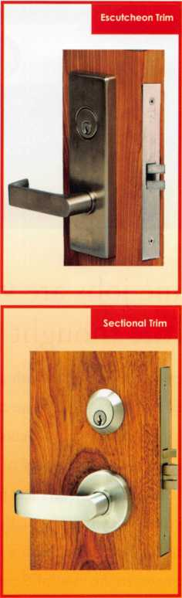

***Save BIG On Maintenance Uniform Look Throughout Your Facility Maintain Existing Keyway & Cylinders***

**♦All brand names and** trademarks are the property of their respective **owners.**

r

Sectional Trim



Escutcheon Trim

|  |  |  |
| --- | --- | --- |
| 1^ |  |  |
| 0 |  | « |
| 0 |  | c |
|  |  | *4j |

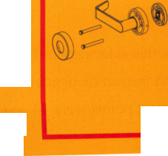

A Little Research Pays Off!

By Greg Perry, CML, CPS

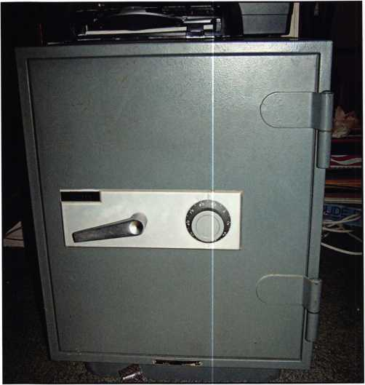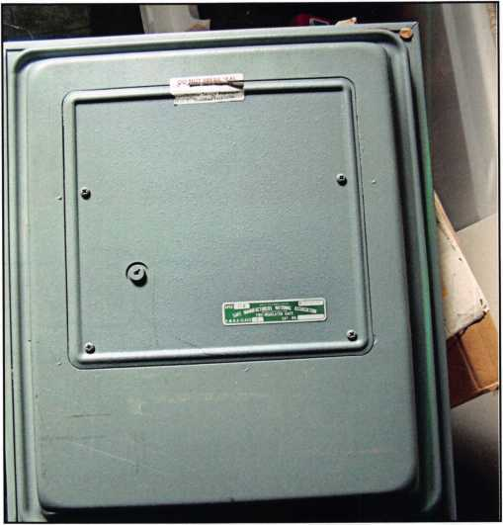

Photo 1

Photo 2

Some jobs are very straightforward and easy, others need a little thought and in some cases, research.

No one knows it all but with a good library you can exceed the average. In some cases you can look really good. This safe carries a Sears nameplate. Sears has pur­chased safes from a variety of manufacturers, for those who are not aware Sears has put their name on all sorts of products they don’t actually make. Like Whirlpool appliances branded Kenmore or Essco hand tools labeled Craftsman. In the case of Sears they used three or four major fire safe brands: Tower safe, Center Mfg.,

Diebold, and Protectall might be found with the Sears name. Round door Sears safes might be Diebold or Amsec.

My first thought when I saw this safe was not Diebold. I had forgotten about them and instead thought either Center or Tower, but the contact points were 44 and 57.

Both of them should have contacts around 99 and 8.1 considered the possibility of the customer changing the combination himself by simply changing the location of the drive cam on the spindle and installing the spline key at a different location. Or, some locks have a square shaft so simply turning the drive cam to another position on the shaft could change the combination. Since the gap between the contact points ruled that out, I had to won­der what lock was inside? Fortunately it was close to quitting time so it gave me a chance to consult my library which is what I should have done before going to the job site. A quick look in my database listed the other safes branded by Sears. Aha! It’s a Diebold.

So how should it be opened? I’ve never seen this safe before so I need a hint. Looking through my library of



Keynotes • June 2007

Die-cast and brass  
or chrome plated to  
better match our  
safes. Slanted and  
attractive keypad.

[www.amsecusa.com](http://www.amsecusa.com) (800) 421-6142

**The new electronic lock**

American Security Products Company • 11925 Pacific Avenue • Fontana, CA 92337

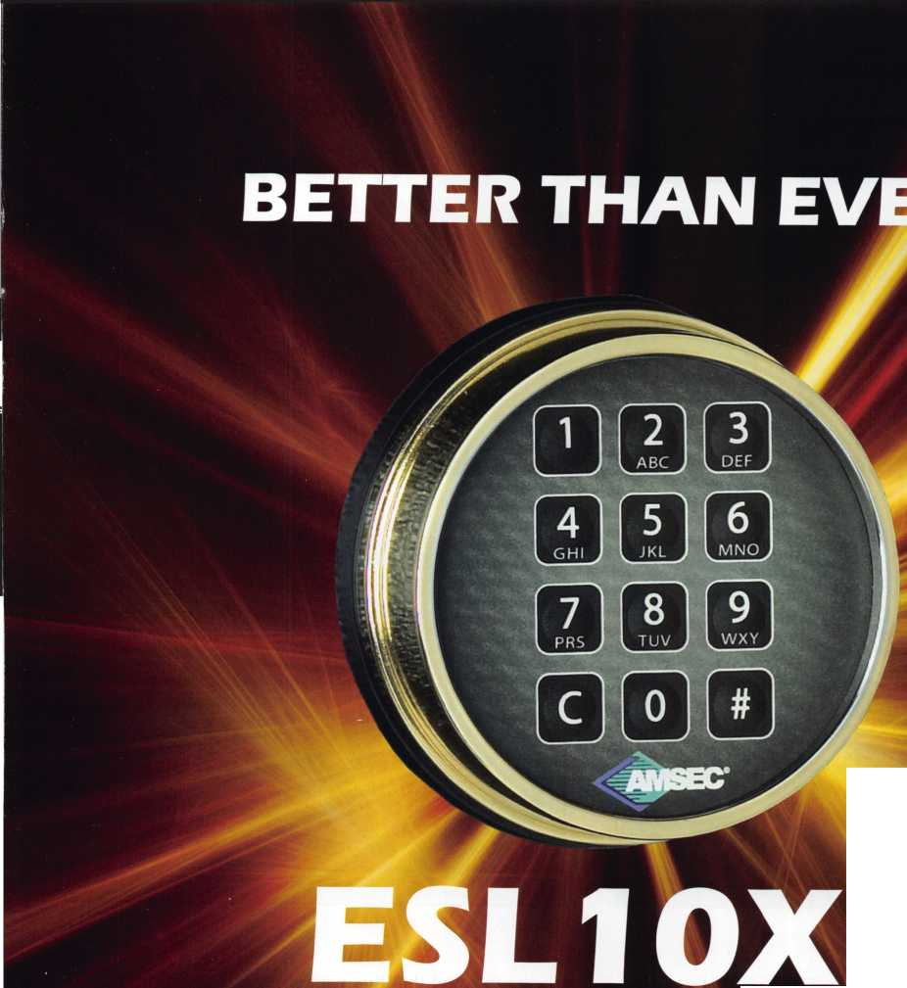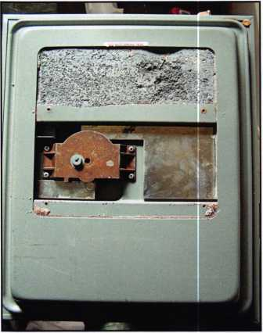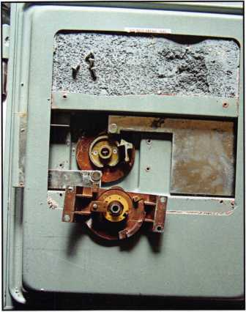

So how should  
it be opened?  
I’ve never seen  
this safe before  
so I need a hint.

Photo 3

Photo 4

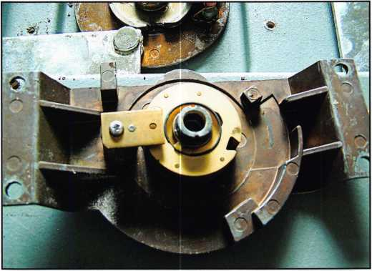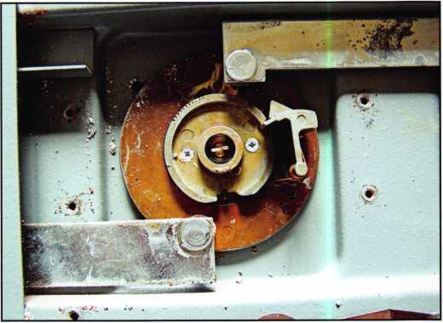

Photo 5

Photo 6

Diebold safes I found a match in The National Locksmith Guide to Safe Opening Volume 2. Dave McOmie recommends in this book to drill outside the dial between 10 to 15 for a scope hole. I chose to drill at 12 about 1/4” off the dial. A better location is a little more away from the dial to avoid nicking the cam, about 2” from dial center. This location requires transferring the gates about 25 numbers to get the fence to drop. If you don’t like an easy drill and transfer you might try drilling 2” at 90. This puts you looking straight in at the bolt. The side of the wheel pack is shrouded so the gap may be a little tight to look to the right with a scope and see past the fence.

Bearing in mind that this was a fire safe, repairs were accomplished with a pop rivet on each side to seal the hole. Welding on sheet metal, burning the paint then try­ing to match the color is never fun. The outside escutcheon can be even more difficult to repair so a pop rivet makes for an easy repair. A few more notes about this safe. The handle is “L” shaped but doesn’t turn. Instead it’s used only to pull the door open. The three wheels are only 1 7/16” in diameter. They seem to be very similar to the wheels used in the S&G government 8077 padlock. Last, but very important, there are no relocks on this particular safe.

Keynotes • June 2007

T.M.

***OPERATOR SAFETY***

Injuries can be virtually eliminated. Ultra Lift does the lift­ing so that operator effort required to complete a move is minimized. Heavy loads are broken back with ease. The operator stays in control by using a combination of motor power, balance and leverage in every phase of a move.

***REDUCE LABOR COSTS***

Fewer people are required for any move with Ultra Lift. Manpower can be scheduled more productively. Labor savings often pay for the Ultra Lift in one month.

***ELIMINATE DAMAGE***

Loads are broken back, set down and moved under power with maximum leverage and operator control. Gentle handling eliminates bumps, bounces and damage to the load and premises.

***INCREASE PROFITS***

Increased operator safety, reduced labor cost and elimina­tion of damage to the load and premises all contribute to significant increases in profits.

FOR LITERATURE, VIDEO OR ON-SITE DEMONSTRATION, WRITE OR CALL:

ULTRA LIFT CORPORATION

475 STOCKTON AVENUE, UNIT E SAN JOSE, CA 95126 800-346-3057 408-287-9400 FAX 408-297-1199 E-mail: [info@ultralift.com](mailto:info@ultralift.com) [www.ultralift.com](http://www.ultralift.com)

ULTRA LIFT supplies the power — so you don't have to. One person can safely and easily handle loads that usually require 2 or 3 people, even up or down stairs. Two people can handle most safes to 1500 pounds. If safety is your concern, ULTRA LIFT is the best move you'll ever make!

U S. PATENT 4.570.953

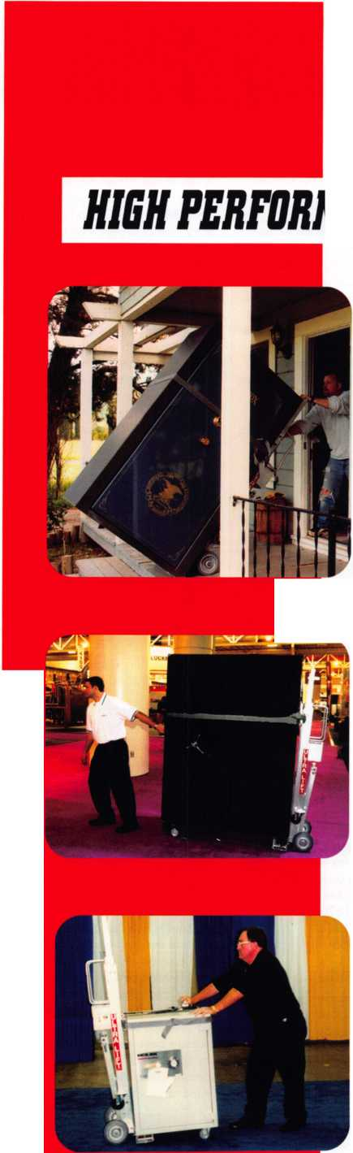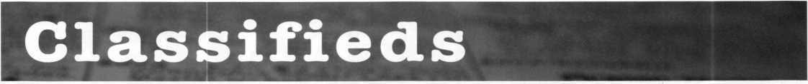

EMPLOYMENT

EMPLOYMENT OPPORTUNITY

Welcome to fabulous Las Vegas! The City of Excitement and Opportunity. Liberty Lock & Safe is looking for experienced and entry-level lock­smiths. Our team of 55 dedicated Security Professionals provides the services of CCTV, Access Control, Hardware Installation and residential commercial and safe services in this great city. We are looking for motivat­ed individuals for our Road Service Department and our Front Counter Department. Top pay for peak per­formers. If you have the skills, we have the work. Benefits include paid vacations, generous commission plan, medical and dental insurance. We provide the company van, you supply your tools. We have regular manufac­turer's in-house training seminars and an excellent support staff to help you be all you can be. If you are an apprentice, our company can hone your skills and turn you into a super- star in minimal time! All we require from you is ambition and drive. Applicants must possess a good driv­ing record, be people oriented, have a neat appearance and pass a back­ground check. Call today 702-871- KEYS, ext 2224 for more information on this exciting opportunity. Email your resume to [james@libertylock.com](mailto:james@libertylock.com) or fax to 702-876-5470.

WORK WITH US

My name is George Klein. I am a 3rd generation locksmith and became owner of John Koons Locksmiths in 1979. The following employees and the year in which they started working with me at Koons Locksmiths:

Gino 1979, Beth 1979, Jim 1986, David 1986, Steve 1993, Kirk 1993, Don 1995, Lew 2002, Lew Jr. 2003, Mark 2003, Josh 2005, Scott 2005, Mike 2005, Kevin 2006, Jeff 2006, Alison 2006. If you are an experi­enced locksmith and want to join us working inside one of our shops or work outside services, please call 1-800-282-8458 or fax a resume to 239-939-5869. John Koons Locksmiths/Fort Myers, Florida.

EMPLOYMENT

San Diego Locksmith and Access Control Company has openings for Locksmiths and Access Control Techs! Grah Safe and Lock is a full service security company that does primarily

commercial, industrial and government work. Master Key Systems, Safe work and Access Control are areas that we keep full schedule. If you know of a hardworking, customer friendly techni­cians, who works now in, or would like to grow into this type of work, have them contact us. Positions to work alone, or as a trainee working with an experienced Locksmith or Safe Tech available. Paying $30K to $60K to start, depending on experience and ability. Visit us online at [www.grahse- curity.com](http://www.grahse-curity.com). Letter of introduction and resume to [glen@grahsecurity.com](mailto:glen@grahsecurity.com) 939 University Ave. San Diego, California 92065

RETIREMENT/COMPANY

EXPANSION

Maziuk Wholesale Distributors, head­quartered in Syracuse, NY has pur­chased the assets of J. Nathan Hardware specialties in Rochester, NY and will begin business operations immediately in the former J. Nathan building at 161 Comfort St.,

Rochester, NY. After 27 successful years in business, Jim and Toni Bono, owners of J. Nathan Hardware Specialties have decided to retire. Tom Enders, a 15 year veteran of J.

Nathan Hardware has joined the Maziuk team in Rochester. Maziuk Wholesale has been a distributor of mechanical and electronic security hardware since 1943, with a main office in Syracuse and branch office in Buffalo. 585-325-3330 [www.maziuk.com](http://www.maziuk.com)

EXPERIENCED LOCKSMITH NEEDED

Experienced commercial locksmith needed for Sacramento, California based locksmith and security compa­ny. No automotive work and limited residential. Knowledge in all phases of commercial locksmithing, including, but not limited to, master key systems, repair/install/service panic hardware door closers, locksets, office furniture. Safes, access control, CCTV and other security/lock related experience a plus.

Medical/Dental/Vision/Chiropractic benefits +401 K. Salary depends on experience between $12-$20 hour. Call 916-569-1640, fax resume to 916-569-1637 or email: [sara@lockworks.us](mailto:sara@lockworks.us)

WANTED

Live, work and play in beautiful Maui, Hawaii. This is a permanent career position for an experienced locksmith, or will consider some training for the right candidate with limited experi­ence. This is your chance to live in paradise. Wages commensurate with experience and abilities. Late model van and tools provided. Great health and dental insurance and benefits. Opportunity and professional growth is encouraged. Applicants must pos­sess a good driving record. Please call 808-280-9805 between the hours of 2pm and 8pm Hawaii time, or send a resume to Island Lock and Safe, 1036 Limahana Place, Lahaina, Maui, HI 96761. We have been in business at the same location for 26 years.

LOCKSMITH WANTED

A southern California locksmith com­pany is looking for an honest, depend­able, reliable and experienced lock­smith. The company has been in busi­ness for 30 years, and is looking for a locksmith to work in both commercial and residential. Salary and commis­sion, plus general insurance, paid vacation and 401 K.

Fax resume to: 760-779-1 81 1

EMPLOYMENT OPPORTUNITY

Experienced Service Technician sought in established company in Central Illinois. Must have good driving record, positive work habits and be neat in appearance. Our company offers a competitive salary with an excellent benefit package - many EXTRAS. Mail or fax resume to Denny at: Dave & Harry Locksmiths, Inc.

1 16 E. University Ave..

Champaign, IL 61 820.

Phone: 217-352-5034.

Fax: 217-352-3505

LOCKSMITH NEEDED

A Raleigh, NC company with over 35 years of service is looking for an experienced team player in all aspects of locksmithing: commercial, residen­tial and automotive. Must have a valid NC locksmith license. We have med­ical, dental and life insurance with paid vacation and holidays. Salary based on experience. For more infor­mation, please call 919-231-8017, ext. 425

EMPLOYMENT OPPORTUNITY IN LAS VEGAS!

A true career opportunity in Las Vegas for enthusiastic and dependable peo­ple! A&B Security Group is seeking entry level or experienced locksmiths and electronic security professionals to join our dynamic and growing security services organization. On the job training and advancement opportuni­ties into many areas such as alarms, CCTV, access control systems, safes and more. We offer: Minimum first year salary $30,000. 401k with matching, Hospitalization package, Vacation package, Paid holidays, Company vehicle and even a reloca­tion allowance! Come work for A&B Security Group in Las Vegas and you’ll stay in Las Vegas! Apply on our website, [www.227lock.com](http://www.227lock.com) or call 702-227-LOCK and ask for Gary or Phil today!

LOCKSMITH WANTED

Locksmith wanted for Southwest Houston, Texas for BMC West. Must have 2 years experience. Drug test, background check and good driving record required. GREAT BENEFITS! Respond to:

[houstonrecruiting@bmcwest.coM](mailto:houstonrecruiting@bmcwest.coM) or fax 281-569-2610

MANAGER OF LOCKSMITH SER­VICES: SEEKING: Manager of Locksmith Services: Successful lock­smith business expanding to Lake and McHenry Counties, Illinois is search­ing for a Manager of Locksmith Services. Our well funded, market driven approach and advertising will provide our Manager with top earn­ings potential. Responsibilities: Help define and build a market leading locksmith service in Lake and McHenry County,IL. Market locksmith services to new commercial, residen­tial and automotive accounts. Identify and develop new locksmiths. Ability to troubleshoot/perform commercial, resi­dential and automotive locksmith duties, such as masterkeying design and records keeping, lock installation, encode locks, key duplication and cut by code, repair and open locks and change combinations using special hand or bench tools and equipment, troubleshoot, repair and replace auto­motive ignition and door locks, etc. Ability to work independently in the performance of assigned tasks, as well as manage other staff in the per­formance of their duties.

Keynotes • June 2007

Qualifications: HS Diploma, GED or equivalent +5 years related commer­cial, residential and/or automotive locksmith experience. Currently have or ability to secure valid Illinois Locksmith License, ability to be bond­ed and possess a valid IL Drivers License. Ability to lift up to 50 lbs. Guaranteed Salary plus Commission opportunity, guaranteed salary com­miserate with experience. Van and equipment provided. To apply email: [LakeCountylL@popalock.com](mailto:LakeCountylL@popalock.com) or call 847-917-5625.

WANTED TO BUY/SELL

WANTED

Best Capping machine. Prefer in nice used condition or easy repairable. Also used Best 1C cores, any keyway, prefer 100's. Please call Randy (909) 795-2320.

WANTED

Blue Punch Key code machine in any keyway, prefer NOT working and inexpensive price. Please call Randy (909) 795-2320.

BUSINESS FOR SALE

LOCKSMITH BUSINESS FOR SALE

Established 12 years in ideal Coastal Community between Santa Barbara and Los Angeles. Great retail location and 3 vans. Lots of top locksmith equipment. Stable income over $ 100,000 per year. Over $ 150,000 in equipment and inventory. Financing and training available. Call Broker, Ken at 805-658-0166.

BUSINESS FOR SALE

In beautiful North East Wisconsin. A complete line one-person locksmith shop. Well established. Includes inven­tory, machines, tools, many commer­cial and governmental accounts.

Doing business since 1986, 13 years in same location. Building sold sepa­rately to buyer of business only. Has 2 rentals up, one down, plus lock shop or you may rent existing location directly from seller. 35 miles from Green Bay in Shawano Wisconsin. Located on the Wolf River and Shawano Lake. Fishing, Hunting, year round sports. Retiring due to health.

For details call between 6:30 am and 5:30 pm. Monday-Friday and 6:30 am and noon Saturday and Sunday. Ask for Jim 715-526-9117.

SPECIAL PRICING ON KWIKSET & SCHLAGE!

While supplies last on the following: Kwikset 242TxUS3 - $30.00 each. 690Tx5 - $15.00 each. 665x5 - $12.00 each. 400x5 - $7.00 each. 341x3 Screen door lock - $7.00 each. Schlage B 162x626 - $16.00 each. All FOB in Michigan. Call Cheryl: A-l Brown Locksmiths 269-983-0569

FOR SALE

Framon II Code machine, including spacing blocks, Framon code book and assorted cutters. Curtis #15 clip­per with 20 depth cluster assemblies, 30 carriages and 28 depth gauges. 1 Keedex mini vats interrogator. 1 set Ford 10 cut tryout keys. 1 GM keying kit #702767. 1 GM 10 cut dash kit #PS3. 2 used 400 hook key cabinets. Approximately 3000 assorted automo­tive key blanks and 30 assorted vats blanks. Some various odds and ends, ignition switches, etc. Asking $2700. Call Al at 407-761-7426. Alternate # 732-841-6562. Please leave message if no answer.

LOCKSMITH:

dential and automotive locksmith duties. Uses machinery, tools, and computer software in the performance of duties. Duties include: master key­ing, record keeping, installation and repair, rekey, programming, and decoding of mechanical and electron­ic locks, cut by code, issue and return keys, have an awareness of all appli­cable codes; promote a safe working environment and practices. Performs other duties as needed. Qualifications: HS Diploma, GED, or equivalent +2 yrs related commercial, residential and/or automotive locksmith experi­ence. Currently have, or ability to secure, valid Illinois Locksmith license, ability to be bonded and possess a valid IL Drivers License. Ability to lift up to 50 lbs. Guaranteed Salary plus Commission opportunity. Van and equipment provided.

To apply, email: [LakeCountrylL@popalock.com](mailto:LakeCountrylL@popalock.com), or call 847-917-5625.

FOR SALE

NGS programmer - $ 1500.

Call 601-624-8185 or email, safecracker [15@aol.com](mailto:15@aol.com)

Own a business in the beautiful Finger Lakes region of upstate New York. Affordable housing, good schools, low cost of living and great year round outdoor recreation. 8 year old well established and grown mobile busi­ness. 70% commercial with excellent reputation in large service area. 1998 Ford 3/4 ton van is a first class shop on wheels. Details and pictures avail­able by email. Approx, value of van and tools - $15,000. Fresh inventory (no junk) valued at $28,000 whole­sale. Annual gross averages around $100,000/year. Sale price $1 10,000. Call 607-739-5171 or [lockdoc@stny.rr.com](mailto:lockdoc@stny.rr.com)

INVENTORY REDUCTION

New old stock inventory of Best and Medeco. Also 3 each Russwin Deadbolts, and 16 each Corbin Locksets. Contact Mitch Miller for list. Email: [mitchellm@gci.net](mailto:mitchellm@gci.net) Fax: 907-488-6341

BUSINESS FOR SALE

Mom and Pop Locksmith and Screen Business for sale in Golden Valley, Arizona. Located between Kingman, AZ and Laughlin, NV in fast growing Mohave County. Health is our reason for selling. Dodge Ram Van and Business have more than $75,000 in equipment and inventory. All is includ­ed in the asking price of $40,000.

We can be reached at 928-565-2294

FOR SALE

ALOA member is selling the below list­ed equipment at well below cost. Member is retiring from automotive locksmithing industry and focusing only on commercial and residential work. TKO Transponder Programming. This tool includes all current software. Framon Sidewinder - NEW. Framon #2 Code Cutter - NEW; never used. Brovo Duplicating Machine - NEW; never used. Transponder Keys for Ford, GM, Honda, Toyota, Chrysler plus many boxes of blanks. Many more items included in sale - too numerous to list. Please call for detail description of other equipment and tools. All original packaging and sell­er has gone to great lengths to insure safe arrival of all items to buyer. Shipping costs to be paid by seller. $6000 asking price - initial cost $1 1,000. Musselwhite Locksmith. 951-537-4779

SECURITY SHOW AND EDUCATIONAL CONFERENCE

Jovan Security Distributors 1 1th Annual Security Show and Educational Conference will be September 28-30, 2007. 2350 Midland Avenue, Toronto, ON MIS 1P8. For more information please call Larry at 416-288-6306

Seeking highly successful locksmith business expanding to Lake and McHenry Counties, Illinois, is search­ing for a licensed locksmith. Responsibilities: Market locksmith serv­ices to new commercial, residential and automotive accounts. Ability to troubleshoot/perform commercial, resi­

FOR SALE

1 Used ILCO 024 Semi-Automatic key machine - $250.00. 1 used HPC Trace A Key Model 6666 Automatic key machine - $250.00. All prices plus shipping. Call 313-881-0280 or email: [eastsidelock@sbcglobal.net](mailto:eastsidelock@sbcglobal.net)

Using a general purpose lubricant? **Be professional!** Use a specially formulated lubricant for the Locksmith and Safe Technician trade. You and your customers will be well pleased. **Guaranteed!**

$48°° + shipping per case.

12-1 loz. cans per case minimum order.  
Order via phone or fax. Credit cards accepted.  
Net 30 W.A.C. or send check with order.

Coast Safe & Lock Co., Inc.

P.0. Box 66257 • Mobile, AL 36606  
(251) 479-5264 • Fax (251) 471-6967

d-d I—

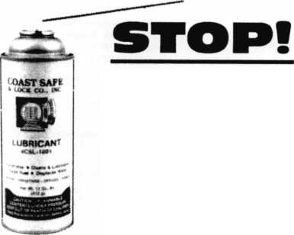

Distributor

**ADEL Fingerprint Technology/**

Phone: 909-595-1222 Fax: 909-595-1667

**Accredited Lock Supply Co.**

Phone: 800-652-2835 Fax: 201-865-2435 [www.acclock.com](http://www.acclock.com)

**American Auto Lock.Com**

Phone: 717-392-6333 Fax: 717-581-8353 [www.americanautolock.com](http://www.americanautolock.com)

**Boyle & Chase Inc.**

Phone: 800-325-2530 Fax: 800-205-3500 [www.boyleandchase.com](http://www.boyleandchase.com)

**Clark Security Products**

Phone: 858-974-6740 Fax: 858-974-6720 [www.clarksecurity.com](http://www.clarksecurity.com)

**Cook's Building Specialties**

Phone: 505-883-5701 Fax: 505-883-5704

**Dire's Lock & Key Company**

Phone: 303-294-0176 Fax: 303-294-0198

**Direct Security Supply, Inc.**

Phone: 800-252-5757 Fax: 800-452-8600

**Doyle Security Products**

Phone: 800-333-6953 Fax: 612-521-0166 [www.doylesecurity.com](http://www.doylesecurity.com)

**Dugmore and Duncan, Inc.**

Phone: 888-384-6673 Fax: 888-329-3846

**E. L. Reinhardt Co., Inc.**

Phone: 800-328-1311 Fax: 651-481-0166 [www.elreinhardt.com](http://www.elreinhardt.com)

**Ewert Wholesale Hardware**

Phone: 800-451-0200 Fax: 708-597-0881

**Foley-Belsaw Company**

Phone: 800-821-3452 Fax: 816-483-5010 [www.foley-belsaw.com](http://www.foley-belsaw.com)

**Fried Brothers Inc.**

Phone: 800-523-2924 Fax: 215-592-1255 [www.fbisecurity.com](http://www.fbisecurity.com)

**H.L. Flake Co.**

Phone: 800-231-4105 Fax: 713-926-3399 [www.hlflake.com](http://www.hlflake.com)

**Hans Johnsen Company**

Phone: 214-879-1550 Fax: 214-879-1530 [www.hjc.com](http://www.hjc.com)

**Hardware Agencies, Ltd.**

Phone: 416-462-1921 Fax: 416-462-1922 [www.hardwareagencies.com](http://www.hardwareagencies.com)

**IDN Incorporated**

Phone: 817-421-5470 Fax: 817-421-5468 [www.idn-inc.com](http://www.idn-inc.com)

|  |  |  |  |
| --- | --- | --- | --- |
|  | a | s s o c i a 1 | e |
|  |  | members |  |

**Instant Hardware Delivery, Inc**

Phone: 800-355-1107 LLC Fax:800-663-8518

**Intermountain Lock & Security**

Phone: 800-453-5386 Fax: 801-485-7205 [www.imlss.com](http://www.imlss.com)

**International Electronics, Inc**

Phone: 800-343-9502 Fax: 617-821-4443

**Jovan Distributors, Inc**

Phone: 416-288-6306

Fax:416-752-8371

[www.jovanlock.com](http://www.jovanlock.com)

**L V Sales Inc**

Phone: 323-661-4746 Fax: 323-661-1314 [www.lvsales.com](http://www.lvsales.com)

**Lockmasters, Inc.**

Phone: 859-885-6041 Fax: 859-885-7093 [www.lockmasters.com](http://www.lockmasters.com)

**Locks Company**

Phone: 800-288-0801 Fax: 305-949-3619

**Locksmith Ledger International**

Phone: 847-454-2700 Fax: 847-454-2759 [www.lledger.com](http://www.lledger.com)

**McDonald Dash Locksmith Sup­ply**

Phone: 800-238-7541 Fax: 901-366-0005 [www.mcdonalddash.com](http://www.mcdonalddash.com)

**Monaco Lock Co.**

Phone: 800-526-6094 Fax: 800-845-5625 [www.monacolock.com](http://www.monacolock.com)

**NLS Lock Supply Dba Nevada Lock Supply**

Phone: 702-737-0500 Fax: 702-737-7134

**Omaha Wholesale Hardware**

Phone: 800-238-4566 Fax: 402-444-1664 [www.omahawh.com](http://www.omahawh.com)

**Phoenix Safe International LLC**

Phone: 765-483-0954 Fax: 765-483-0962 www. phoenixsafeusa .com

**Positive Identity Solutions**

Phone: 704-663-1175 Fax: 704-660-1301 www. pids-usa .com

**Security Distributors Inc**

Phone: 800-333-6953 Fax: 612-524-0166

**Security House**

Phone: 905-669-5300 Fax: 905-660-6313 [www.securityhouselock.com](http://www.securityhouselock.com)

**Southern Lock and Supply Co.**

Phone: 727-541-5536 Fax: 727-544-8278 [www.southernlock.com](http://www.southernlock.com)

**Stone & Berg Wholesale**

Phone: 800-225-7405 Fax: 800-535-5625

**Streetwise Security Products**

Phone: 252-830-5577 Fax: 252-830-5542

**The Locksmith Store Inc.**

Phone: 847-364-511 1 Fax: 847-364-5125 [www.locksmithstore.com](http://www.locksmithstore.com)

**The Ultimate Distribution Compa­ny**

Phone: 254-681-2277 Fax: 254-953-4933 [www.ultimatelocksales.com](http://www.ultimatelocksales.com)

**Timemaster Inc.**

Phone: 859-259-1878 Fax: 859-255-0298 [www.time-master.com](http://www.time-master.com)

**Top Notch Distributors, Inc.**

Phone: 800-233-4210 Fax: 800-854-4146 [www.topnotch.bz](http://www.topnotch.bz)

Turn 10 Wholesale

Phone: 800-848-9790 Fax: 800-391-4553

**U.S. Lock Corp.**

Phone: 800-925-5000 Fax: 800-338-5625 [www.uslock.com](http://www.uslock.com)

Manufacturer

**A & B Safe Corporation**

Phone: 800-253-1267 Fax: 856-863-1208 [www.a-bsafecorp.com](http://www.a-bsafecorp.com)

**ABUS KG**

Phone: 492-335-634151 Fax: 233-563-4130 [www.abus.com](http://www.abus.com)

**ABUS Lock Company**

Phone: 800-352-2287 Fax: 602-516-9934 [www.abus.com](http://www.abus.com)

**Access Security Products Ltd.**

Phone: 905-337-7874 Fax: 905-337-7873 [www.access-safe.com](http://www.access-safe.com)

**Adams Rite Mfg Company**

Phone: 800-872-3267 Fax: 800-232-7329 [www.adamsrite.com](http://www.adamsrite.com)

**Adrian Steel Company**

Phone: 800-677-2726 Fax: 517-265-5834 [www.adriansteel.com](http://www.adriansteel.com)

**Advanced Diagnostics USA Inc**

Phone: 650-876-2020 Fax: 650-876-2022 [www.autokeys.com](http://www.autokeys.com)

**Alarm Controls Corporation**

Phone: 631-586-4220 Fax: 631-586-6500 [www.alarmcontrols.com](http://www.alarmcontrols.com)

**All Five Tool Company, Inc.**

Phone: 860-583-1691 Fax: 860-583-4516 [www.all5tool.com](http://www.all5tool.com)

**American Security Products**

Phone: 909-685-9680x2013 Fax: 909-685-9685 [www.amsecusa.com](http://www.amsecusa.com)

**BWD Lockcraft**

Phone: 973-728-3707 Fax: 973-728-3731 [www.bwdautomotive.com](http://www.bwdautomotive.com)

**Bianchi USA, Inc.**

Phone: 800-891-2118 Fax: 216-803-0202 [www.bianchi](http://www.bianchi) 1770usa.com

**Buddy Products**

Phone: 312-733-6400 Fax: 312-733-8356 [www.buddyproducts.com](http://www.buddyproducts.com)

**CCL Security Products**

Phone: 800-733-8588 Fax: 847-537-1800 [www.cclsecurity.com](http://www.cclsecurity.com)

**CompX Security Products**

Phone: 864-297-6655 Fax: 864-297-9987 [www.compx.com](http://www.compx.com)

**D&D Technologies (USA), Inc.**

Phone: 714-677-1300x292 Fax: 714-677-1299 [www.ddtechglobal.com](http://www.ddtechglobal.com)

**DETEX Corp.**

Phone: 800-729-3839 Fax: 830-620-6711 [www.detex.com](http://www.detex.com)

**Don-Jo Manufacturing, Inc.**

Phone: 978-422-3377 Fax: 978-422-3467 [www.don-jo.com](http://www.don-jo.com)

**Door Controls International**

Phone: 800-742-3634 Fax: 800-742-0410 [www.doorcontrols.com](http://www.doorcontrols.com)

**Door Jamb Armor**

Phone: 201-490-5381 Fax: 201-490-5389 [www.djarmor.com](http://www.djarmor.com)

**Doorking Inc.**

Phone: 800-826-7493 Fax: 310-641-1586 [www.doorking.com](http://www.doorking.com)

**Dorma Architectual Hardware**

Phone: 717-336-3881 Fax: 717-336-2106 [www.dorma-usa.com](http://www.dorma-usa.com)

**DynaLock Corp**

Phone: 860-582-4761 Fax: 860-585-0338 [www.dynalock.com](http://www.dynalock.com)

**E-Lock USA**

Phone: 434-589-5913 Fax: 434-589-3738 [www.e-lock-usa.com](http://www.e-lock-usa.com)

**FireKing Security Group**

Phone: 800-457-2424 Fax: 800-896-6606 [www.fireking.com](http://www.fireking.com)

**Framon Manufacturing Company Inc.**

Phone: 989-354-5623 Fax: 989-354-4238

[www.framon.com](http://www.framon.com)

**G-U Hardware Inc.**

Phone: 757-877-9020 Fax: 757-877-9720 [www.g-u.com](http://www.g-u.com)

**HPC, Inc.**

Phone: 847-671-6280 Fax: 847-671-6343

[www.hpcworld.com](http://www.hpcworld.com)

**HY-KO Products Co.**

Phone: 330-467-7446 Fax: 330-467-7442

**Hammerhead Industries, Inc.**

Phone: 805-658-9922 Fax: 805-658-8833

[www.gearkeeper.com](http://www.gearkeeper.com)

**Ingersoll Rand Security Technologies**

Phone: 317-810-3801 Fax: 317-805-5779

[www.schlagelock.com](http://www.schlagelock.com)

**Jackson Corporation**

Phone: 323-269-8111 Fax: 800-888-6855

[www.jacksonexit.com](http://www.jacksonexit.com)

**Jet Hardware Mfg., Co.**

Phone:718-257-9600

Fax:718-257-0973

[www.jetkeys.com](http://www.jetkeys.com)

**KABA ILCO Corp.**

Phone: 252-446-3321 Fax: 252-446-4702

[www.kaba-ilco.com](http://www.kaba-ilco.com)

**KEY-BAK/West Coast Chain Mfg.**

Phone: 909-923-7800 Fax: 909-923-0024

[www.keybak.com](http://www.keybak.com)

**Kenstan Lock Company**

Phone: 516-576-9090x315

Fax:516-576-0100

[www.kenstan.com](http://www.kenstan.com)

**Keri Systems Inc.**

Phone: 408-435-8400 Fax:408-435-7163

[www.kerisys.com](http://www.kerisys.com)

**Kustom Key Inc.**

Phone: 800-537-5397 Fax: 800-235-4728

[www.kustomkey.com](http://www.kustomkey.com)

**LAB Security**

Phone: 800-243-8242 Fax: 860-583-7838

[www.labpins.com](http://www.labpins.com)

**La Gard Inc.**

Phone: 310-325-5670 Fax: 310-325-5615

[www.lagard.com](http://www.lagard.com)

**LockPicks.Com/Brockhage Tools**

Phone: 408-437-0505 Fax: 408-516-9642

Keynotes • June 2007

**associate**

**members**

**Lucky Line Products, Inc.**

Phone: 858-549-6699 Fax: 858-549-0949 [www.luckyline.com](http://www.luckyline.com)

**M.A.G. Manufacturing**

Phone: 714-891-5100 Fax: 714-892-6845 [www.magmanufacturing.com](http://www.magmanufacturing.com)

**MPT Industries, Inc.**

Phone: 973-989-9220 Fax: 973-989-9234 [www.mptindustries.com](http://www.mptindustries.com)

**MUL-T-LOCK USA, Inc.**

Phone: 800-562-3511 Fax: 973-778-4007 [www.mul-t-lockusa.com](http://www.mul-t-lockusa.com)

**Major Mfg, Inc.**

Phone: 714-772-5202 Fax: 714-772-2302 [www.majormfg.com](http://www.majormfg.com)

**Maxcess Card Systems Ltd**

Phone: 800-713-4823 Fax: 650-692-9410 www. maxcess-ca rd. com

**Medeco Security Locks**

Phone: 540-380-5000 Fax: 540-380-5010 [www.medeco.com](http://www.medeco.com)

**Mil-Comm Products Co Inc**

Phone: 201-935-8561 Fax: 201-935-6059

**Pacific Lock Company**

Phone: 888-562-5565 Fax: 818-678-6600 [www.paclock.com](http://www.paclock.com)

**Promet Safe Inc.**

Phone: 860-436-6246 Fax: 860-436-6876 [www.promet-safe.com](http://www.promet-safe.com)

**Protex Safe Co., LLC**

Phone: 818-610-8030 Fax: 818-610-8004 [www.protexsafe.com](http://www.protexsafe.com)

**ROFU International Corp.**

Phone: 253-922-1828 Fax: 253-840-7272 [www.rofu.com](http://www.rofu.com)

**Rutherford Controls Int'l Co.**

Phone: 519-621-7651 Fax: 519-621-7939 [www.rutherfordcontrols.com](http://www.rutherfordcontrols.com)

**STRATTEC Security Corp.**

Phone: 414-247-3333 Fax: 414-247-3564 [www.aftermarket.strattec.com](http://www.aftermarket.strattec.com)

**Sargent & Greenleaf, Inc.**

Phone: 859-885-9411 Fax: 859-885-3063 [www.sargentandgreenleaf.com](http://www.sargentandgreenleaf.com)

**Sargent Manufacturing Co.**

Phone: 800-727-5477 Fax: 888-863-5054 [www.sargentlock.com](http://www.sargentlock.com)

**Schwab Corp.**

Phone: 765-447-9470 Fax: 765-447-8278 [www.schwabcorp.com](http://www.schwabcorp.com)

**Securifort Inc**

Phone: 819-359-2226 Fax: 819-359-2218 [www.securifort.com](http://www.securifort.com)

**Securitron Magnalock Corp.**

Phone: 775-355-5625 Fax: 775-355-5636 [www.securitron.com](http://www.securitron.com)

**Security Door Controls**

Phone: 805-494-0622 Fax: 805-494-8861 [www.sdcsecurity.com](http://www.sdcsecurity.com)

**Security Solutions**

Phone:405-376-1600 Fax: 405-376-6870 [www.securitysolutions-usa.com](http://www.securitysolutions-usa.com)

**Select Engineered Systems**

Phone: 305-823-5410 Fax: 305-823-5215 [www.selectses.com](http://www.selectses.com)

**Townsteel, Inc.**

Phone: 626-858-5080 Fax: 626-858-3393 [www.townsteel.com](http://www.townsteel.com)

**Trine Access Technology**

Phone:718-829-2332

Fax:718-829-6405

[www.trineonline.com](http://www.trineonline.com)

**Videx Inc.**

Phone: 541-758-0521 Fax: 541-752-5285 [www.videx.com](http://www.videx.com)

**WIKK Industries Inc.**

Phone: 414-421-9490

Fax:414-421-3158

[www.wikk.com](http://www.wikk.com)

**WMW Innovation Company**

Phone: 888-474-2341 [www.sure-strike.com](http://www.sure-strike.com)

Service

Organization

**Allstate Insurance Company**

Phone: 847-551-2181 Fax: 847-551-2732 [www.allstate.com](http://www.allstate.com)

**Cardservice Mobile Solutions**

Phone: 561-210-8488 Fax: 561-953-6268 [www.cardservicems.com](http://www.cardservicems.com)

**Cross Country Automotive Services**

Phone: 800-541-2262 Fax: 781-393-0256 [www.argosi.com](http://www.argosi.com)

**HRH Insurance**

Phone: 817-462-3630 Fax: 817-462-3680 [www.hrh.com](http://www.hrh.com)

**Massglass & Door Service**

Phone: 888-742-8837 Fax: 805-497-2255 [www.massglass.com](http://www.massglass.com)

**Red Hawk**

Phone: 901-332-2911 Fax: 901-332-2878 [www.webstersinc.com](http://www.webstersinc.com)

**SalesGenie.Com**

Phone: 402-593-4500 [www.salesgenie.com](http://www.salesgenie.com)

**The Mechanic Group, Inc.**

Phone: 845-735-0700 Fax: 845-735-8383 [www.mechanicgroup.com](http://www.mechanicgroup.com)

**Don’t miss these great BUSINESS SEMINARS at the 2007 RLOR Convention and Security Expo!**

Jim Thomas presents  
an 8-hour workshop  
"Negotiate to Win - the  
21 Rules for Successful  
Negotiating" on  
Thursday, July 26, 2007

Jim Thomas is the choice of

U.S. presidents and their staffs for negotiating  
coaching and advice. Based in Washington, DC,  
Jim is a world-renowned consultant to billion-dol-  
lar-plus corporations and an undisputed master of  
high-performance negotiating. When Fortune 100  
companies demand that their people learn negoti-  
ation skills from only the best, they unhesitatingly  
pick Jim. His presentations on negotiating have  
been enthusiastically received by tens of thou-  
sands in the United States and abroad.

ALOA 2007 Keynote  
address is presented  
by Jack Sims: "Most  
Marketing Stinks...But  
Your Locksmith  
Business can Smell  
Like Money" on Friday,  
July 27, 2007. PLUS

"Growing your Locksmith Business into  
a Big Brand!" on Saturday, July 28,  
2007

"In the world of marketing and growing your busi­ness, Jack Sims is unique. He started two brand leading companies of his own and helped Polaroid, British Airways, Burger King and General Foods and others to become market leaders. If you want to grow your brand, he is the best in the business"

Larry Swensen - Senior Director of Marketing, Jarden Consumer Solutions, Global Appliiances.

Tom Egelhoff will be  
presenting two half day  
workshops:

"How Good Customer  
Service Can Hurt You"  
on Saturday, July 28,  
2007

"How to Create a Successful Sales Team and Keep Them Motivated" on Sunday, July 29, 207

Tom helps small-business owners learn to do their own advertising and marketing. After 35 years of making hundreds of business mistakes he decided it was time to use the education of those mistakes to help others not to make the same ones.

In 1980, Tom joined a video company that had four stores. When he left five years later they had over 40. Eventually the chain was sold to Blockbuster Video for $12 million dollars.

*

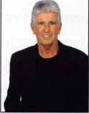

IkP the forms in uour BLOB Conuention and securitu Expo

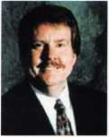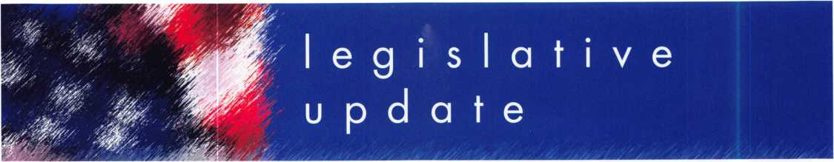

**NUMEROUS LEGISLATIVE ACTIVITIES WILL KEEP YOU INFORMED AT CON­VENTION!!!**

Find out the latest happening in your state capi- tol. Learn about ALOA's efforts against "phony locksmiths". Come to the "State of the States Roundtable". This is just some of what you can expect this year from the Legislative Department at the ALOA 2007 Convention and Security Expo in Charlotte, North Carolina. Here are the highlights:

***Friday, July 27 thru Sunday July 29, 2007***

***Noon to 5pm (Noon to 4pm Sunday) LEGISLATIVE BOOTH AT SECURITY EXPO***

This year, 20 lucky people who stop by the Legislative Booth and sign up for the Legislative Action Network will have a chance to win a

free Richard Petty Riding Experience© Ride-A- Long. Experience real life racing thrills by rid­ing shotgun in a 2-seat stock car driven by pro­fessional instructor for a simulated 3-lap NASCAR qualifying run at speeds exceeding 150 MPH! Also at the booth, we'll have infor­mation on all bills, and legislation in your state PLUS our "Locksmith Lobbying for Licensing: A Guide for Influencing your State Legislature and Governor." FREE Convention merchandise for our Legislative Action Network Council ($100+ donation) members.

***Saturday, July 28, 2007 3pm to 4:30pm***

***STATE OF THE STATES ROUNDTABLE***

This meeting is designed as a forum for ALOA chapters and local/state regional locksmith associations to share information about the state of locksmithing in their region. It's a dynamic way to share ideas. Primarily for the Chairman, President and Legislative representa­tive from each organization, all locksmiths are encouraged to participate. This is the perfect opportunity to learn about what's going on in the industry across the nation.

Keynotes • June 2007

**THANK YOU LEGILSATIVE ACTION NETWORK COUNCIL MEMBERS!**

The following ALOA members contributed $100 or more to the Legislative Fund to help raise the stan­dards of our profession through the legislative process by making sure that locksmiths have the final say in how our industry will be run.

Kevin E. Ahrens CRL

Robert J. Akin Jr

Eugene Anderson RL, CPP, AHC

Robert A. Arthur RL

Larry H. Bachman CML

Ryan L. Badeaux

Dana L. Barnum CML

Lawrence I. Barrett Sr, RL

Lawrence I. Barrett Jr

Robert Barton

John S. Becker Sr

Mark E. Blum CML, CPS

Rolando Bouza

Donald L. Brown CML

Adrian D. Busse CPL, CPS

Elliott Paul Connor CML

John H. Cosby CPL

Olen Cothron CRL

Paul Davis

Michael T. Day CPL

Mark Dorn

Mike D. Dunkerley CPL Richard L. Dyer CPL, CPS Joe Earley R. Terry Earll CML Alfred W. Evans Ronald G. Ferrill Glen W. Fessenden CML Michael Festa CRL Patrick A. Filholm CPL

Michael L. Finn CML Dan Floeck

Vincent L. Formon CML, CPS

Charles J. Gladd CML, CPS

Daniel M. Graffeo CRL, CMST

John J. Greenan CML, CPS

Grant H. Grein CRL

Kenneth A. Griffin CML, CPS

Lee Griggs

Eugene Gyure CRL

Neil A. Harding

Jim D. Harnden CRL

Paul W. Hawk CRL, CPS

Lucian Lee Hayden

Philip J. Heath

Scott L. Henke CPL, CPS

Edward J. Henning CPL

Claude A. Hensley

Jim W. Hetchler

Andy Hilverda

Edward A. Hite CML

John A. Ilk CRL, CPS

Howard H. Johnsen

Thomas R. Johnston

Martin J. Jordan RL

Joseph S. Kasenchak

David A. Keenan CRL

Danny R. Knight CRL

Karl R. Kretsch CRL

Richard A. Labbe

Clifford D. Lipscomb CML, CPS

Henry R. Lucier

Jack C. Magee III

William L. Mandlebaum CPL

Karen Maples

Michael Marmo

Julie McCluney CRL

William J. McElheney CML

Thomas B. McKinney

Dennis D. McLeod

Barry L. McMenimon CPL

Christopher L. Melton CPL

Jerry L. Miller

Jimmy L. Mowry CML

John W. Murphy CRL

Autley Musselwhite

Bruce S. Nemec CML

Sean Olden

Tom W. Olson

Kevin R. O'Toole

Joseph H. Peek

John H. Perron RL

Richard R. Peterkin CPL

Joe Pielech CRL, CPS

Don F. Ponder CRL

John R. Presti Sr

James P. Pritchett CPL

Gordon R. Racine CML

Daniel J. Rackliffe CML

Richard D. Rebori Richard J. Reichert CRL Jon Rickard Gerald G. Roraback Donald E. Rule CML Frank A. Schlesser Arthur M. Shoob Jr, CML Larry E. Smith CPL Lawrence F. Smith Jr, CML David P. Snyder Sr Marian M. Swann CRL Thomas W. Tate CRL David D. Taylor CRL Walter F. Taylor Jim Thomas

Rodney E. Thompson CML

John E. Trone Jr, CPL

Thomas G. Vandersteen CML, CPS

Marion J. Walters CRL

Paul A. Wesoly RL

James J. White

Eric H. Wilderson

Roger G. Williams CRL

John H. Williamson CRL

James M. Young

William L. Young CML, CPS

Glenn Younger

Mehdi Zahedi CRL

Kathy A. Zaniolo CML

**Become a Legislative Action Network Council Member TODAY!**

If you contribute $100 or more to the Legislative Action Fund you become a member of the presti­gious Legislative Action Network (LAN) Council. To learn more, go to: [www.aloa.org/legislation](http://www.aloa.org/legislation)

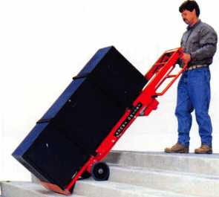

***Lectro Truck***

STAIR CLIMBINGi SYSTEM

Visit us online at:

[www.lectrotruck.com](http://www.lectrotruck.com)

...or call us today at:

800-619-0625

The Lectro-Truck will make it easier for you to break back a load, climb and descend steps, and even load onto your truck or trailer!

Save on damage costs.

Save on injury costs.

Save on labor costs.

The bottom line: You save money!!

The Lectro-Truck makes this all possible - all while having a 1500 # capacity!! Call us today to find out what you have been missing.

Keynotes • June 2007

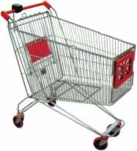

keynotes

Buyer's

Marketplace

|  |  |
| --- | --- |
| AJEU/ | FROM A & B SAFE CORP. |
|  | A & B Chest  Model WS-0 |
| 3  ■ 1 w | Equipped with dual key, combination or electronic locking slot optional |
| A & B SAFE CORPORATION | |
| 114 S. Delsea Drive, Suite 3 Glassboro, NJ 08028-6237 | |
| 856-863-1186 | Fax 856-863-1208 |

IN-STOCK...MORE SAFES

*FREE Freight Program*

*(30 States)*

AMSEC FireKing liariall HAYMAN MEIUNK **y/CTO/Z**

**TURfl 1©**

**WHOLESALE SERVICE**

800-848-9790

Punch SARGENT blanks to factory specifications.

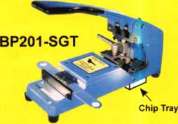

Available Exclusively from:

**Locksmithing, Uni. LLC  
302-575-0993  
[www.sargentpunch.com](http://www.sargentpunch.com)**

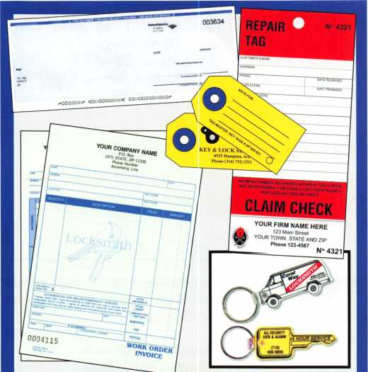

|  |  |
| --- | --- |
| Professional Busi | iness Products |
| Invoices Tags  Checks Key Fobs  Business Magnets  Cards Labels | Call for a free brochure and samples  1-800-355-6322  [www.pbp2000.com](http://www.pbp2000.com) |

.

You need it When?

**How about now!? :-)**



Another Special  
Value-added Benefit to your

ALOA Membership! Click here

iL

[www.clearstar.com/ALOA](http://www.clearstar.com/ALOA)



Keynotes • June 2007

Since 1912

The Locksmith Supplier

800-231-4105

**BMP KEYS...**



**NEED A HANDOUT EXPLAINING BUMPING?**

Bumping has become a hot topic in the news lately,  
and your customers might have questions for you...

Let HL Flake’s “Bump Key” Postcards  
help educate your customers!

Lock Bumping

R

tf

***W//***

RECEIVE 100 POSTCARDS FREE!

**WITH YOUR NEXT** $250 **ORDER**

***\*MENTION COUPON CODE “BUMPIOO” WITH YOUR SALES REP  
* LIMIT - ONE FREE SET PER CUSTOMER***

**Full color postcards are ideal for mailing to your customers,  
leaving on your shop counter, or handing out on service calls.**

***Additional postcards available* @ a *very LOW price!***

***Call for details 800-231-4105***

Craft

your own career

in Locksmithing

Learn to be a locksmith at our conveniently  
scheduled hands-on morning program. Classes  
are given from 7:30 am - 12:30 pm. Over nine  
months you will learn to service, install and  
bypass a wide variety of locking devices including

residential, commercial and automotive locks. Master keying, electronic  
access, and safe manipulation round out a curriculum which is updated  
annually to incorporate the latest industry advancements. September and  
February admissions.

Other full-time courses offered are • Bookbinding • Cabinet & Furniture Making • Carpentry • Preservation Carpentry • Jewelry Making & Repair • Piano Technology • Violin Making & Repair

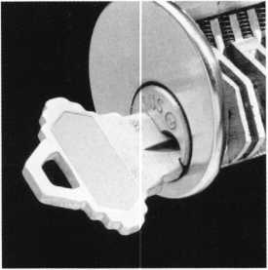

Financial aid is available for qualified students. Accredited member ACCSCT. Non-accredited workshops 1 week to 3 months also offered.

NOKTH-BENNET-STREET-SCHGDL

AN EDUCATION IN CRAFTSMANSHIP 39 North Bennet St. • Boston, MA 02113 • (617) 227-0155

[www.nbss.org](http://www.nbss.org)

120 Glasgow Avenue, Inglewood, CA 90301 U.S.A. T: 310-645-0023 1-800-826-7493 F: 310-641 -1586 E-mail: [info@doorking.com](mailto:info@doorking.com) [www.doorking.com](http://www.doorking.com)

**How Can a Simple Little Box**

**Deliver So Much?**

ACCESS CONTROL SOLUTION*

W-A' for over fifty years

The DKS 1838 is a two-door controller that is much more than that.

For starters, it easily expands to control up to  
16 doors. Reporting capabilities are included,  
which makes the DKS 1838 ideal for small  
businesses, office buildings, factories,  
industrial sites, apartment complexes,  
condominiums, gated communities...

And more:

* elevator option to control 4 elevators  
  serving up to 64 floors each, with  
  floor access restrictions built-in
* anti-pass back for complete control  
  into, and out of, secured areas
* live transactions - view activity  
  in real time on your computer
* interfaces with card readers,

RF controls, keypads, etc.

* access control for up to  
  3000 users

And that’s not all.

Call today and let us show you how DKS can simplify your life.

DoorKing telephone entry systems have always been our preferred systems, because they can fit any application we Ve ever run across - small and simple to large and complex.1

Rich Gonzales

Vice President

Mid Atlantic Entry Systems LLC Abingdon MD

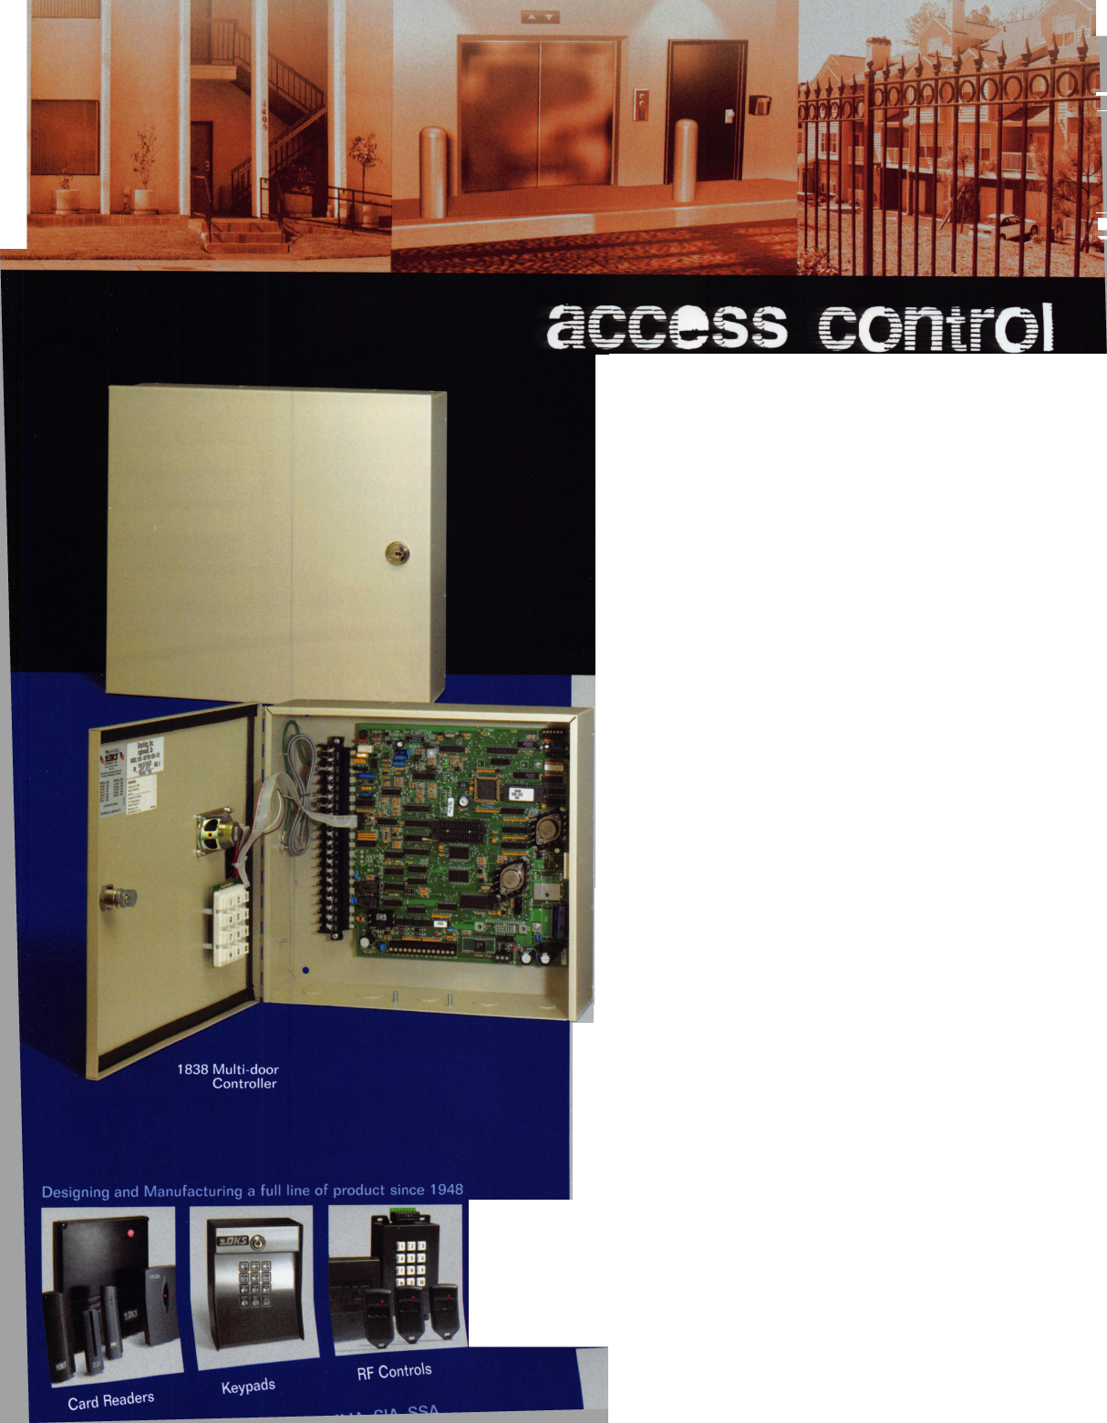

ABC KEY  
USA

555-1212

**EASTER LOCK & KEY k 325-3535 /**

USDVA

ILLINOIS

DUPLICATION

PROHI3ITED

**Jet**

**Exclusives**

**Uni Bow Neuter Bow Personal Line**

***JET HARDWARE***

***800 HinaHal\** c**

***MANUFACTURING corp***

**Smart Clone**

**For All Cloneable Keys... Including Ford, Infiniti & Toyota**

**Smart Clone Key Blanks**

**Largest Selection of Groovy Keys... Anywhere**

**View Our Complete Line  
of Professional Locksmith Hardware at...**

**[www.jetkeys.com](http://www.jetkeys.com)**

**Precision Key Machines and Cutters**

**Professional Products for Professional Locksmiths**

**Automotive**

**Transponder**

**Keys**

**Displays and Key Assortments**

**250 Bin Packs**

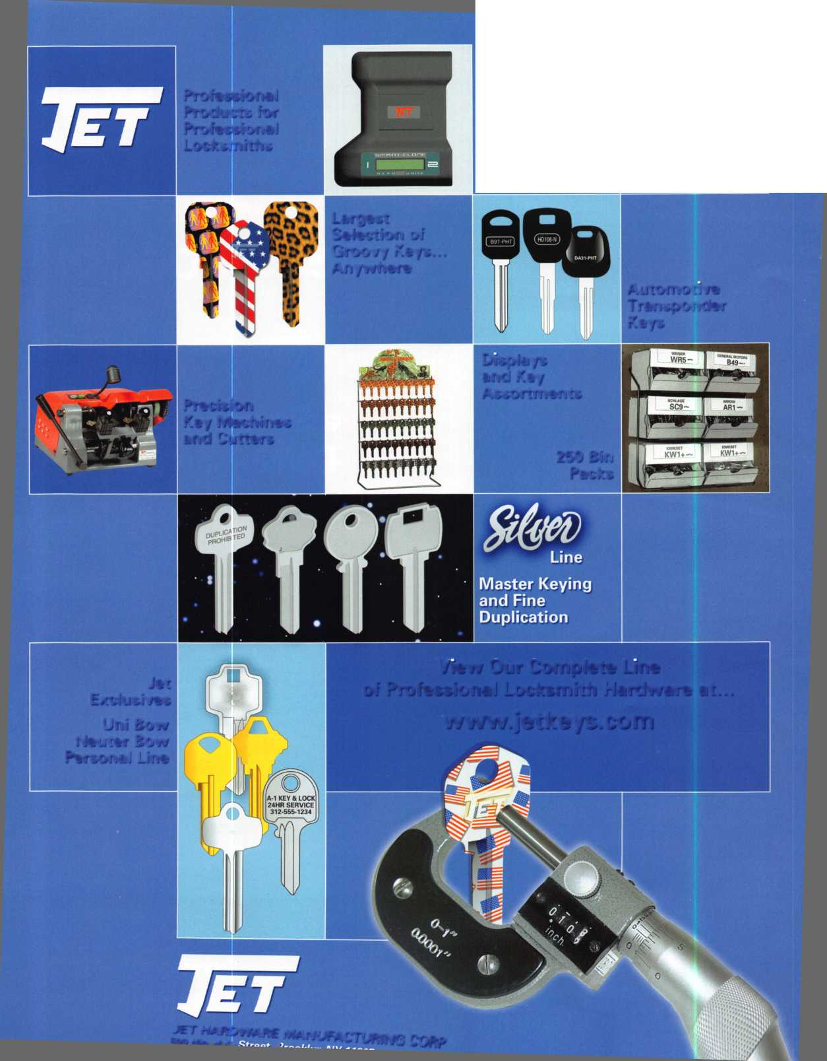

Proven **Protection Where It’s**

e Hinge Shields fit around the existing or hinges and help prevent hinges from ing kicked in

E Door Shield

e Door Shield reinforces the lock area of 3 door and helps prevent the door from lifting when kicked. Low profile model available in colors to match your locks

I Jamb Shield

ie backbone of the system, the Jamb lield is a 48" long sleeve that wraps ound the lock side of the doorjamb, aking it extremely difficult to kick in. he Jamb Shield comes sizes to fit andard (5.5") and Universal (5" to 12") ck spacing. Jamb and hinge shields

Needed Most

**A unique system that  
reinforces the key strike  
points on entry doors  
and repairs damage  
from previous kick-ins**

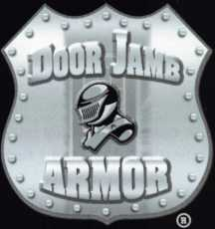

**Because You Can’t Afford False Security ®**

Current security products only alert homeowners that they have already been violated.

Your customers will actually be able to sleep secure the night after a break-in. Helps eliminate tenant initiated damage and secures vacant units for landlords.

This Will Change Your Business

* **You** should make $1,000 on every call that you answer with this product
* Calling a carpenter to fix shattered jambs costs you money
* This will help you sell more high-end deadbolts

Ml n **ham iai akI/** i **a/i + K a** n\ / I Anrllnrrlo 9

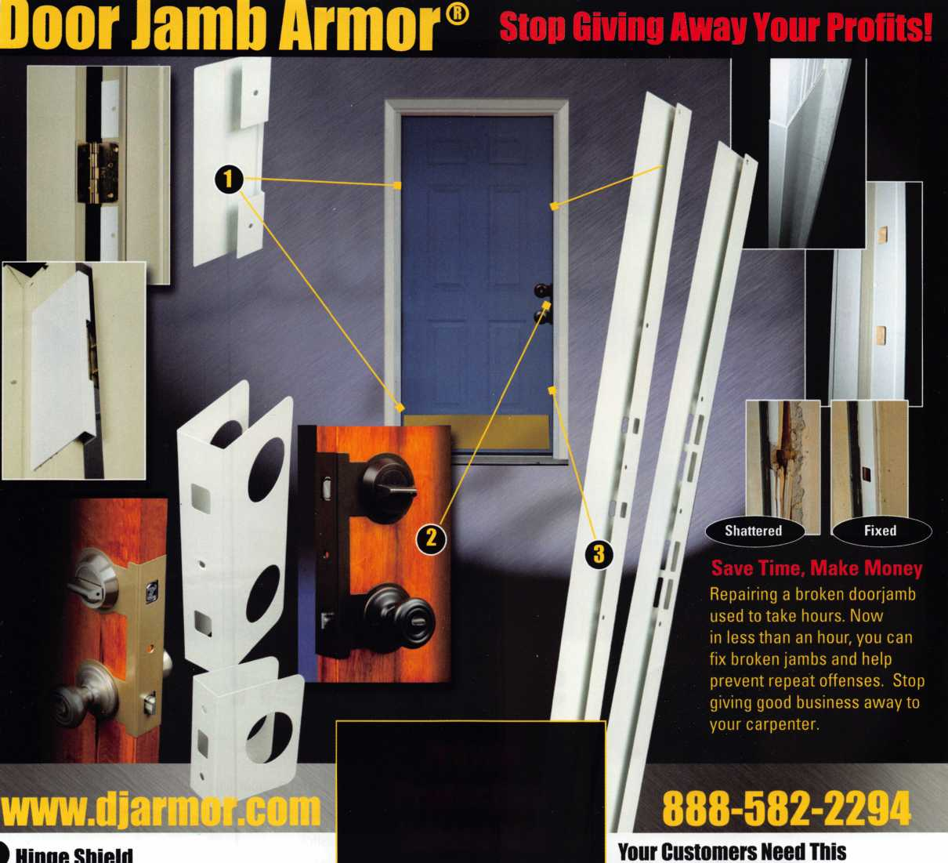

**SearchAlert**

* Available in a variety of colors and styles
* Recognized & Accepted by the TSA
* Security Window cannot be altered with a paper clip
* Security Window can only be reset by a person knowing the combination
* Zinc Die Cast Body (Not Brittle Plastic)
* Steel Shackle is virtually unbreakable

Security Window

O

**Red Window:**

Luggage has been searched.

O

**Green Window:**Lock Not Opened.

The new SearchAlert Security window changes color from Green to Red when the TSA secured access device is used to open the lock, or when an unauthorized person has opened the lock using a counterfeit opening device. Travelers will now know when their SearchAlert Classic locks have been opened, and whether their bags have been searched by a TSA agent, or violated by an

unknown person. Protected by U.S. Patents 6,877,345 and 7,007,521. The Design of the Lock is a Registered Trademark9 of The Eastern Company.

***The name you can Trust for Travel safety, security it accountability.***



**Security Products** A **Division of** The **Eastern Company A Proud Union Company. (S.E.I.U.)** 301 West Hintz Road | Wheeling, IL 60090 | Telephone: 800.733.8588 | Fax: 847.537.1881 **[www.cclsecurity.com](http://www.cclsecurity.com)**



**TRAVEL SENTRY**

**APPROVED**

